Service Delivery Indicators (SDI)

Development Research Group (DECRG)

March 17, 2021

# Descriptive Results

Using SDI surveys of 9,712 health facilities and 87,155 healthcare providers in 11 Sub-Saharan countries, this paper provides a descriptive analysis of the healthcare landscape in these Sub-Saharan African countries.

# Facility Level Results

Table 1 depicts the number of facilities by country based on the three different facility types. Kenya and Nigeria lead with the largest number of facilities regardless of facility type.

Table 1: Facility Type by Country

|  |  |  |  |  |
| --- | --- | --- | --- | --- |
|  | Hospitals | Health Centers | Health Posts | All Health Facilities |
|  | N | N | N | N |
|  | (%) | (%) | (%) | (%) |
| Guinea Bissau 2018 | 6 | 124 | 0 | 130 |
|  | (4.6) | (95.4) | (0.0) | (100.0) |
| Kenya 2012 | 51 | 139 | 96 | 286 |
|  | (17.8) | (48.6) | (33.6) | (100.0) |
| Kenya 2018 | 285 | 594 | 2159 | 3038 |
|  | (9.4) | (19.6) | (71.1) | (100.0) |
| Madagascar 2016 | 37 | 316 | 91 | 444 |
|  | (8.3) | (71.2) | (20.5) | (100.0) |
| Malawi 2019 | 38 | 9 | 148 | 195 |
|  | (19.5) | (4.6) | (75.9) | (100.0) |
| Mozambique 2014 | 101 | 847 | 158 | 1106 |
|  | (9.1) | (76.6) | (14.3) | (100.0) |
| Nigeria 2013 | 16 | 67 | 172 | 255 |
|  | (6.3) | (26.3) | (67.5) | (100.0) |
| Niger 2015 | 411 | 1458 | 516 | 2385 |
|  | (17.2) | (61.1) | (21.6) | (100.0) |
| Sierra Leone 2018 | 30 | 109 | 397 | 536 |
|  | (5.6) | (20.3) | (74.1) | (100.0) |
| Tanzania 2014 | 16 | 46 | 118 | 180 |
|  | (8.9) | (25.6) | (65.6) | (100.0) |
| Tanzania 2016 | 27 | 83 | 270 | 380 |
|  | (7.1) | (21.8) | (71.1) | (100.0) |
| Togo 2014 | 30 | 91 | 262 | 383 |
|  | (7.8) | (23.8) | (68.4) | (100.0) |
| Uganda 2013 | 9 | 133 | 252 | 394 |
|  | (2.3) | (33.8) | (64.0) | (100.0) |
| *N* | 1057 | 4016 | 4639 | 9712 |

Numbers in parenthesis are row percentages

Figure 1 displays the leading facility type within each country and as one can see health centers are the most common type of health facilities across all the countries.

Figure 1: Facility Type by Country

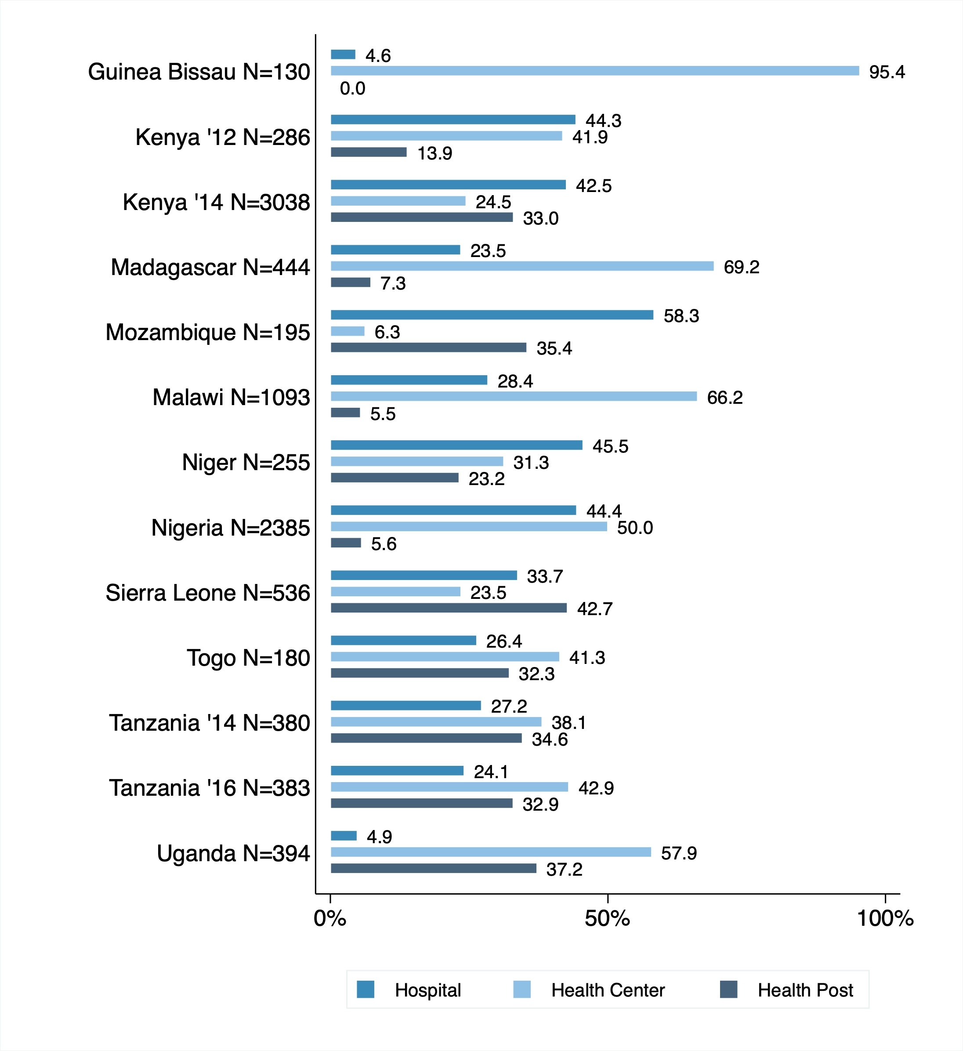

Figure 2 disaggregates facility type by rural and urban regions within each country.

Figure 2: Facility Type by Region

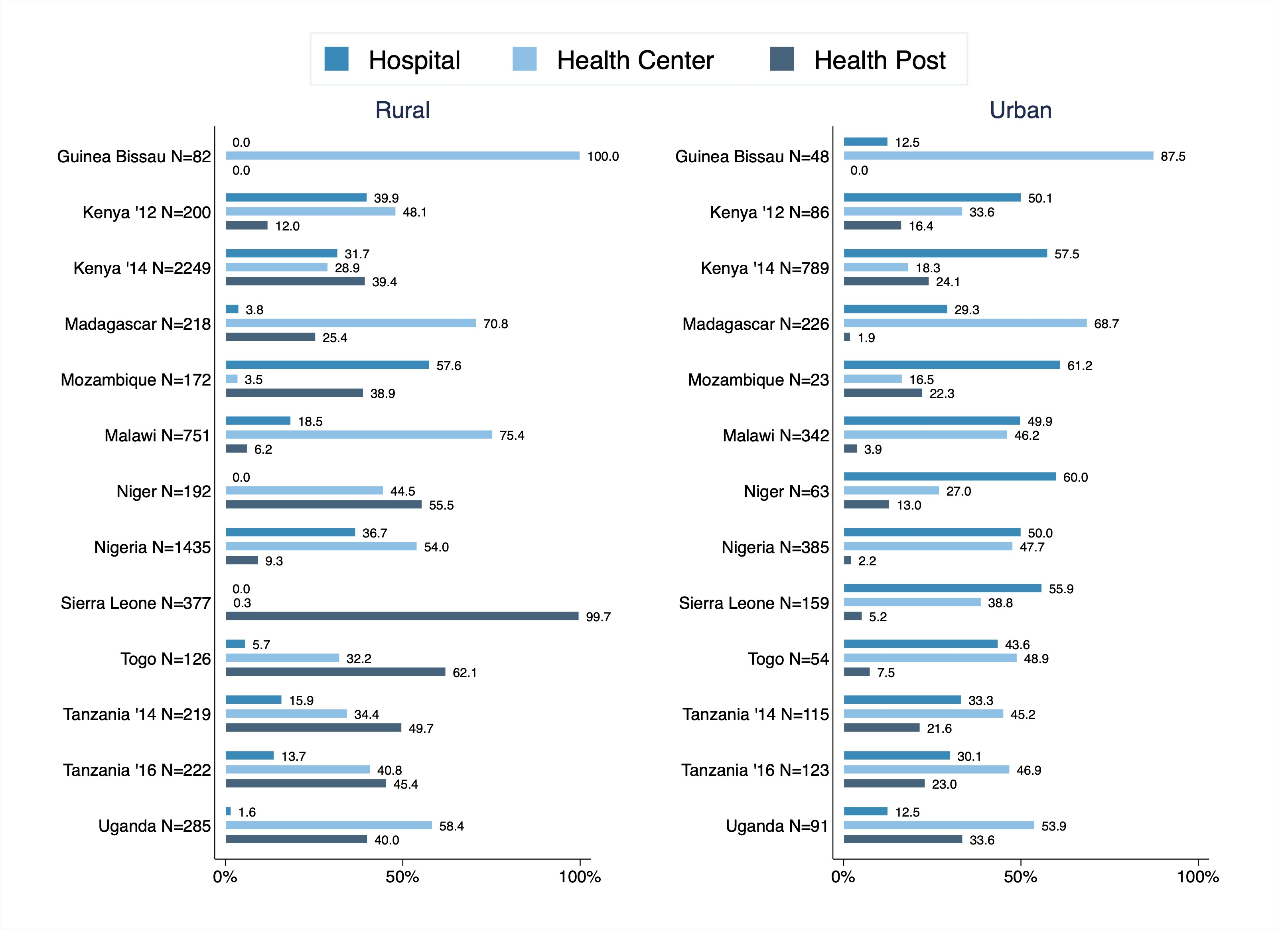

# Provider Level Results

The results in this section displays all the descriptive results of all the health providers that the SDI team were able to interview on their visits to rural and urban health facilities across the 11 countries in Sub-Saharan Africa. One will notice that majority of the health providers are female and are predominately nurses or other health care professionals.

## Gender Breakdown

Table 2 shows the gender breakdown of health providers in each country and the average age. Majority of the health providers are below the age of 40 and are mostly female.

Table 2: Provider Gender & Age Descriptive Stats

|  |  |  |  |  |
| --- | --- | --- | --- | --- |
|  | Female Providers | Male Providers | All Health Providers | Average Age |
|  | N | N | N | N |
|  | (%) | (%) | (%) | (min-max) |
| Guinea Bissau 2018 | 60 | 70 | 130 | 37.8 |
|  | (46.2) | (53.8) | (100.0) | (24-63) |
| Kenya 2012 | 1922 | 1209 | 3131 | 37.0 |
|  | (61.4) | (38.6) | (100.0) | (18-73) |
| Kenya 2018 | 13697 | 10706 | 24403 | 35.9 |
|  | (56.1) | (43.9) | (100.0) | (19-85) |
| Madagascar 2016 | 1332 | 868 | 2200 | 41.7 |
|  | (60.5) | (39.5) | (100.0) | (17-73) |
| Mozambique 2014 | 1405 | 1567 | 2972 | 33.2 |
|  | (47.3) | (52.7) | (100.0) | (18-77) |
| Malawi 2019 | 5956 | 6935 | 12891 | 37.0 |
|  | (46.2) | (53.8) | (100.0) | (15-86) |
| Niger 2015 | 921 | 406 | 1327 | 35.2 |
|  | (69.4) | (30.6) | (100.0) | (18-72) |
| Nigeria 2013 | 14042 | 7151 | 21193 | 39.5 |
|  | (66.3) | (33.7) | (100.0) | (15-82) |
| Sierra Leone 2018 | 3019 | 2036 | 5055 | 38.4 |
|  | (59.7) | (40.3) | (100.0) | (16-76) |
| Togo 2014 | 695 | 669 | 1364 | 38.8 |
|  | (51.0) | (49.0) | (100.0) | (17-74) |
| Tanzania 2014 | 2881 | 1578 | 4459 | 40.0 |
|  | (64.6) | (35.4) | (100.0) | (19-85) |
| Tanzania 2016 | 3402 | 1734 | 5136 | 38.4 |
|  | (66.2) | (33.8) | (100.0) | (15-77) |
| Uganda 2013 | 1483 | 859 | 2342 | 33.9 |
|  | (63.3) | (36.7) | (100.0) | (19-76) |
| *N* | 50815 | 35788 | 86603 |  |

Numbers in parenthesis are row percentages

Figure 3 depicts the gender breakdown by facility type.

Figure 3: Staff Occupation by Facility Type

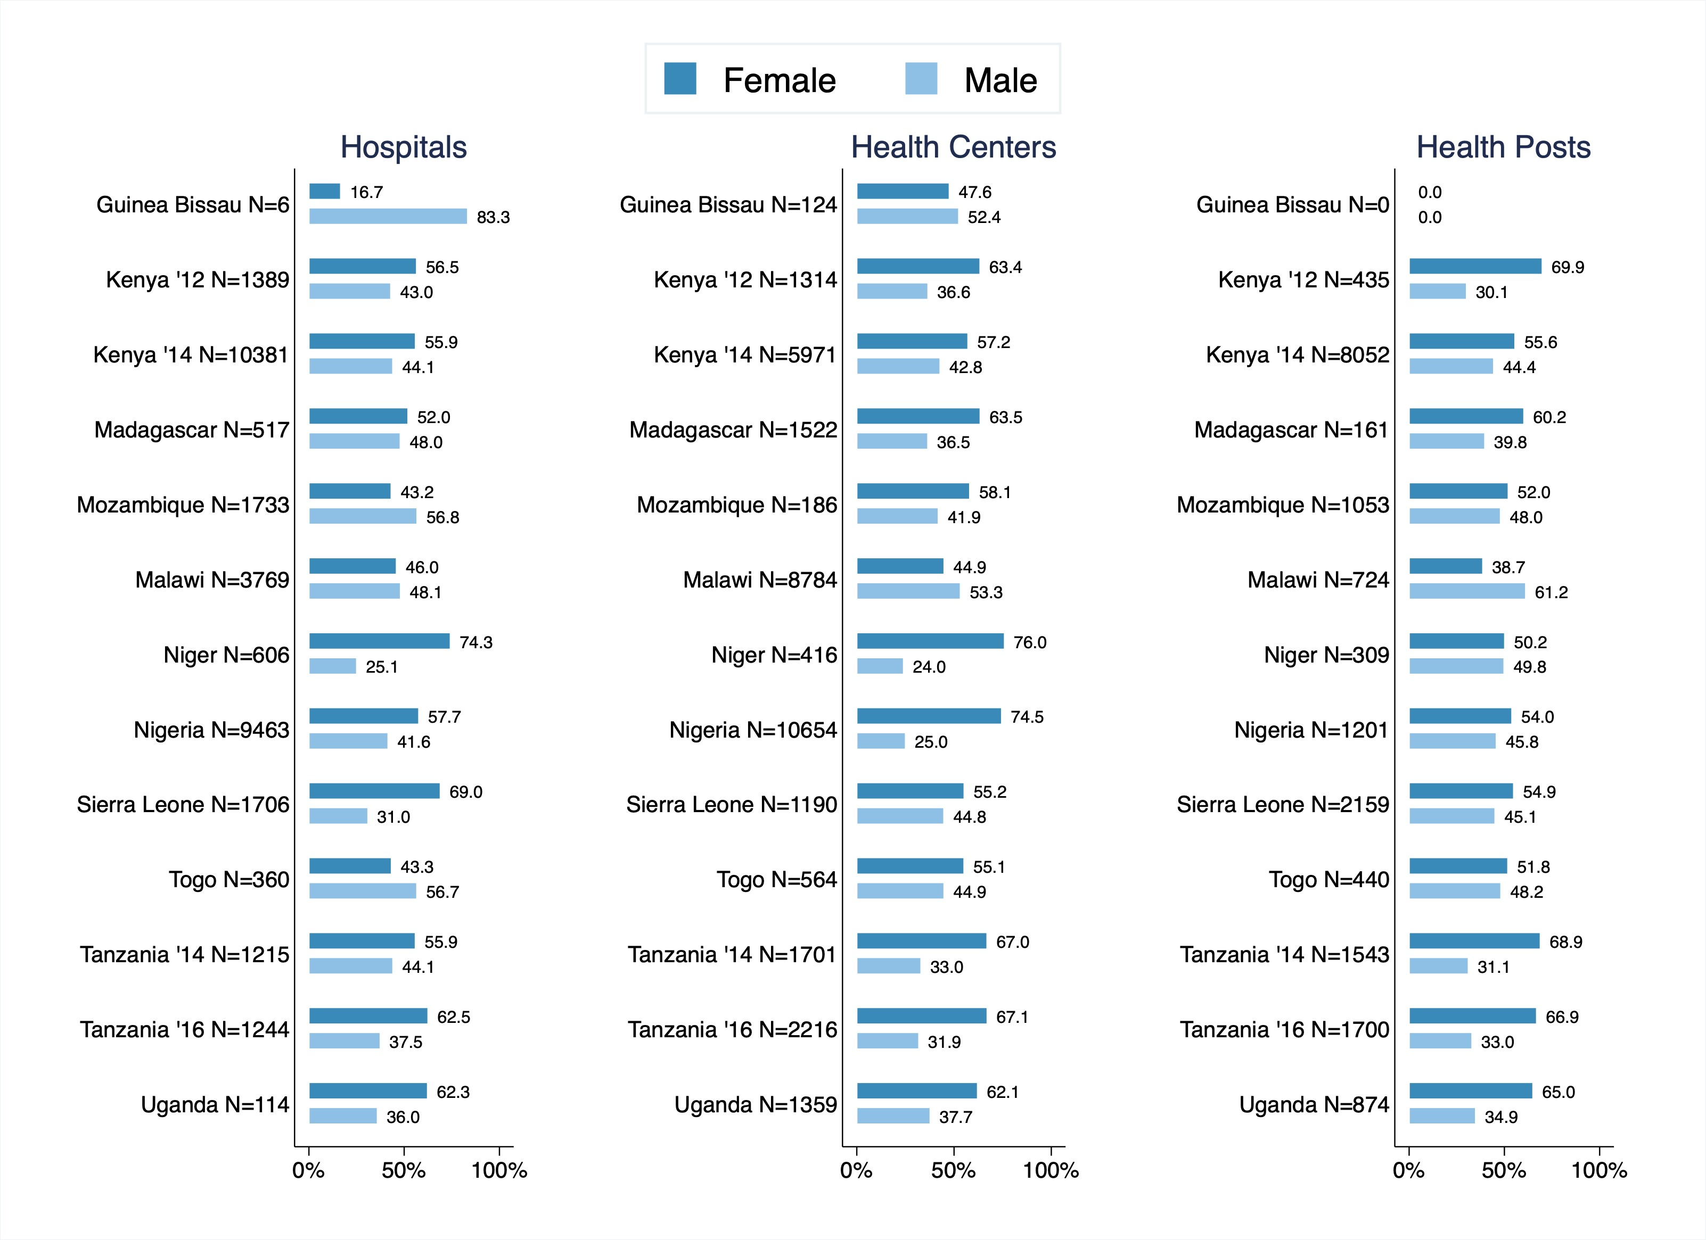

Table 3 displays the gender breakdown at hospitals.

Table 3: Provider Gender & Age Descriptive Stats at Hospitals

|  |  |  |  |  |
| --- | --- | --- | --- | --- |
|  | Female Providers | Male Providers | All Health Providers | Average Age |
|  | N | N | N | N |
|  | (%) | (%) | (%) | (min-max) |
| Guinea Bissau 2018 | 1 | 5 | 6 | 37.7 |
|  | (16.7) | (83.3) | (100.0) | (32-56) |
| Kenya 2012 | 785 | 597 | 1382 | 38.4 |
|  | (56.8) | (43.2) | (100.0) | (20-68) |
| Kenya 2018 | 5808 | 4573 | 10381 | 36.3 |
|  | (55.9) | (44.1) | (100.0) | (20-85) |
| Madagascar 2016 | 269 | 248 | 517 | 41.7 |
|  | (52.0) | (48.0) | (100.0) | (20-70) |
| Mozambique 2014 | 749 | 984 | 1733 | 33.3 |
|  | (43.2) | (56.8) | (100.0) | (18-77) |
| Malawi 2019 | 1732 | 1812 | 3544 | 35.4 |
|  | (48.9) | (51.1) | (100.0) | (18-75) |
| Niger 2015 | 450 | 152 | 602 | 35.2 |
|  | (74.8) | (25.2) | (100.0) | (19-63) |
| Nigeria 2013 | 5460 | 3933 | 9393 | 40.7 |
|  | (58.1) | (41.9) | (100.0) | (17-82) |
| Sierra Leone 2018 | 1177 | 529 | 1706 | 37.8 |
|  | (69.0) | (31.0) | (100.0) | (18-72) |
| Togo 2014 | 156 | 204 | 360 | 41.3 |
|  | (43.3) | (56.7) | (100.0) | (22-63) |
| Tanzania 2014 | 679 | 536 | 1215 | 40.3 |
|  | (55.9) | (44.1) | (100.0) | (19-74) |
| Tanzania 2016 | 778 | 466 | 1244 | 41.1 |
|  | (62.5) | (37.5) | (100.0) | (15-72) |
| Uganda 2013 | 71 | 41 | 112 | 35.9 |
|  | (63.4) | (36.6) | (100.0) | (20-62) |
| *N* | 18115 | 14080 | 32195 |  |

Numbers in parenthesis are row percentages

Table 4 shows the gender breakdown at health centers.

Table 4: Provider Gender & Age Descriptive Stats at Health Centers

|  |  |  |  |  |
| --- | --- | --- | --- | --- |
|  | Female Providers | Male Providers | All Health Providers | Average Age |
|  | N | N | N | N |
|  | (%) | (%) | (%) | (min-max) |
| Guinea Bissau 2018 | 59 | 65 | 124 | 37.8 |
|  | (47.6) | (52.4) | (100.0) | (24-63) |
| Kenya 2012 | 833 | 481 | 1314 | 35.9 |
|  | (63.4) | (36.6) | (100.0) | (18-72) |
| Kenya 2018 | 3414 | 2557 | 5971 | 34.8 |
|  | (57.2) | (42.8) | (100.0) | (20-82) |
| Madagascar 2016 | 966 | 556 | 1522 | 41.9 |
|  | (63.5) | (36.5) | (100.0) | (20-73) |
| Mozambique 2014 | 108 | 78 | 186 | 35.4 |
|  | (58.1) | (41.9) | (100.0) | (22-59) |
| Malawi 2019 | 3944 | 4680 | 8624 | 37.5 |
|  | (45.7) | (54.3) | (100.0) | (15-86) |
| Niger 2015 | 316 | 100 | 416 | 35.1 |
|  | (76.0) | (24.0) | (100.0) | (18-69) |
| Nigeria 2013 | 7934 | 2668 | 10602 | 38.6 |
|  | (74.8) | (25.2) | (100.0) | (15-75) |
| Sierra Leone 2018 | 657 | 533 | 1190 | 38.2 |
|  | (55.2) | (44.8) | (100.0) | (20-75) |
| Togo 2014 | 311 | 253 | 564 | 37.8 |
|  | (55.1) | (44.9) | (100.0) | (20-67) |
| Tanzania 2014 | 1139 | 562 | 1701 | 39.7 |
|  | (67.0) | (33.0) | (100.0) | (19-76) |
| Tanzania 2016 | 1486 | 707 | 2193 | 37.0 |
|  | (67.8) | (32.2) | (100.0) | (20-72) |
| Uganda 2013 | 844 | 513 | 1357 | 33.4 |
|  | (62.2) | (37.8) | (100.0) | (19-72) |
| *N* | 22011 | 13753 | 35764 |  |

Numbers in parenthesis are row percentages

Table 5 shows the gender breakdown at health posts.

Table 5: Provider Gender & Age Descriptive Stats at Health Posts

|  |  |  |  |  |
| --- | --- | --- | --- | --- |
|  | Female Providers | Male Providers | All Health Providers | Average Age |
|  | N | N | N | N |
|  | (%) | (%) | (%) | (min-max) |
| Guinea Bissau 2018 | 0 | 0 | 0 | 0 |
|  | (0) | (0) | (0) | (0) |
| Kenya 2012 | 304 | 131 | 435 | 35.8 |
|  | (69.9) | (30.1) | (100.0) | (20-73) |
| Kenya 2018 | 4475 | 3576 | 8051 | 36.2 |
|  | (55.6) | (44.4) | (100.0) | (19-85) |
| Madagascar 2016 | 97 | 64 | 161 | 39.5 |
|  | (60.2) | (39.8) | (100.0) | (17-72) |
| Mozambique 2014 | 548 | 505 | 1053 | 32.7 |
|  | (52.0) | (48.0) | (100.0) | (20-72) |
| Malawi 2019 | 280 | 443 | 723 | 39.4 |
|  | (38.7) | (61.3) | (100.0) | (20-65) |
| Niger 2015 | 155 | 154 | 309 | 35.5 |
|  | (50.2) | (49.8) | (100.0) | (19-72) |
| Nigeria 2013 | 648 | 550 | 1198 | 38.9 |
|  | (54.1) | (45.9) | (100.0) | (19-70) |
| Sierra Leone 2018 | 1185 | 974 | 2159 | 39.1 |
|  | (54.9) | (45.1) | (100.0) | (16-76) |
| Togo 2014 | 228 | 212 | 440 | 38.0 |
|  | (51.8) | (48.2) | (100.0) | (17-74) |
| Tanzania 2014 | 1063 | 480 | 1543 | 40.3 |
|  | (68.9) | (31.1) | (100.0) | (19-85) |
| Tanzania 2016 | 1138 | 561 | 1699 | 38.4 |
|  | (67.0) | (33.0) | (100.0) | (19-77) |
| Uganda 2013 | 568 | 305 | 873 | 34.2 |
|  | (65.1) | (34.9) | (100.0) | (19-76) |
| *N* | 10689 | 7955 | 18644 |  |

Numbers in parenthesis are row percentages

## Age Ranges

Figures 4,5, 6 & 7 depicts histograms of the ages of doctors and nurses within in each country.

Figure 4: Age of Staff Occupation by Country

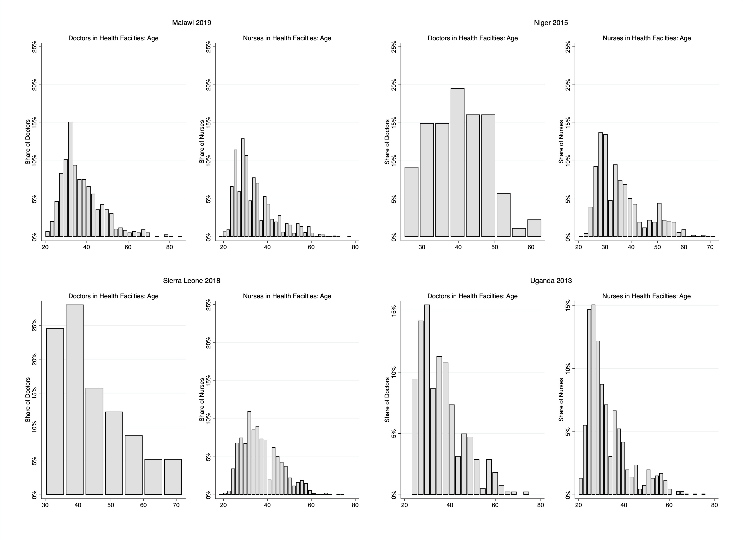

Figure 5: Age of Staff Occupation by Country

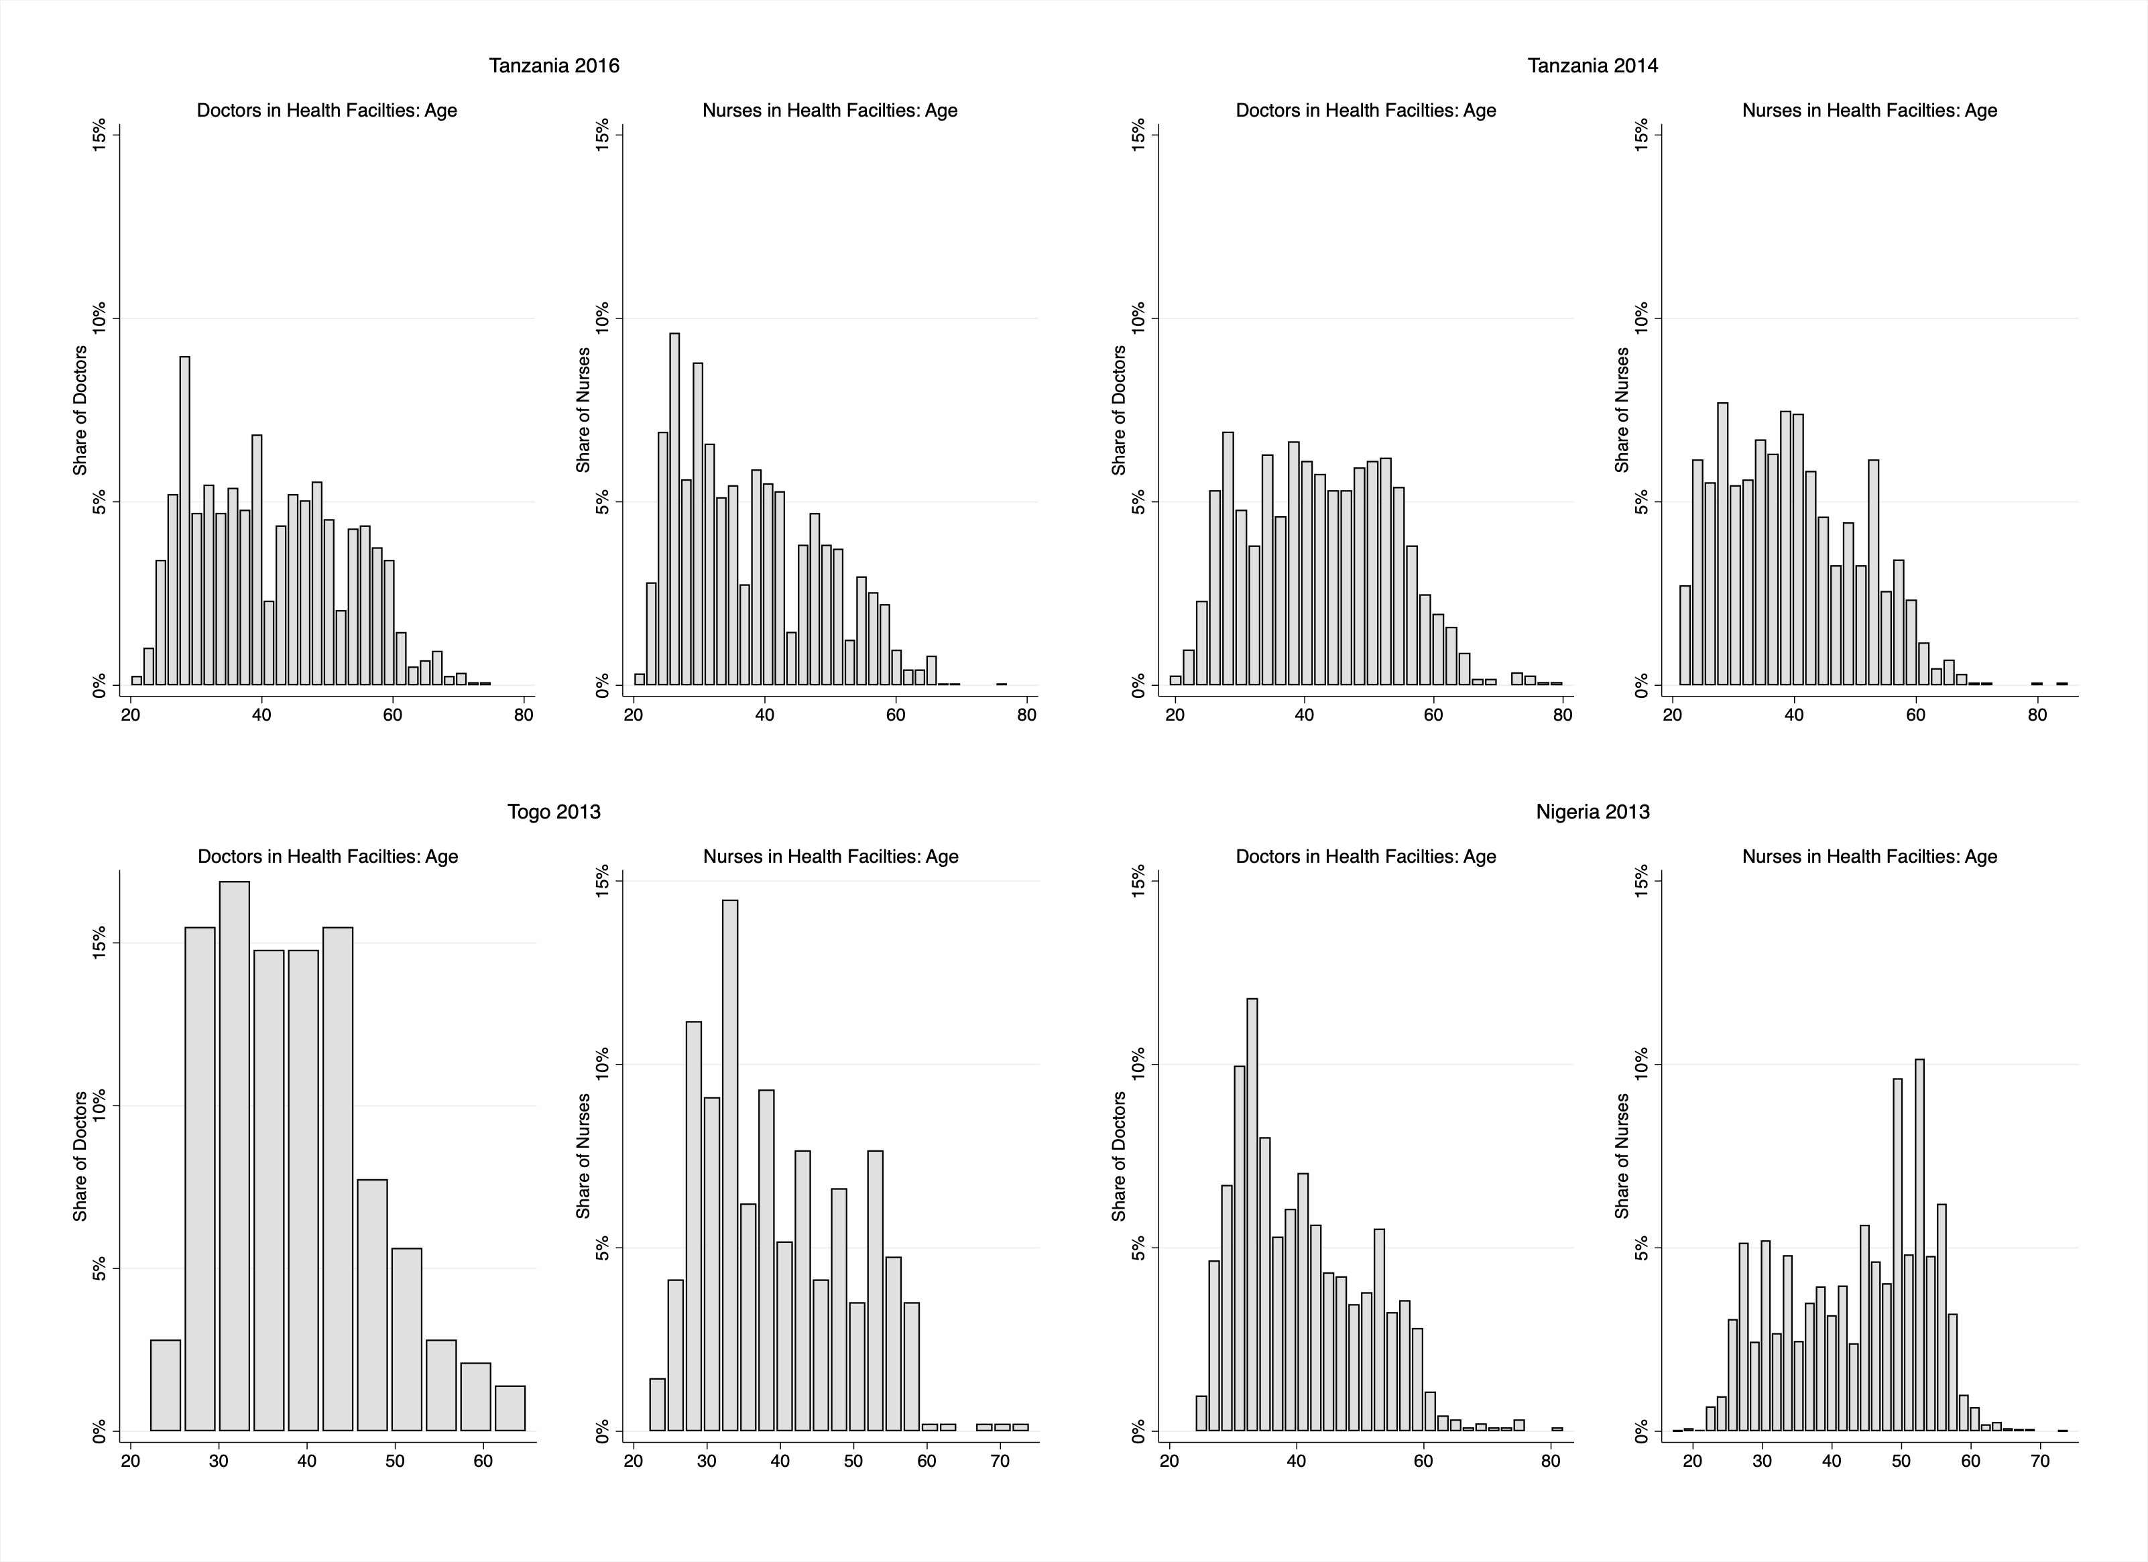

Figure 6: Age of Staff Occupation by Country

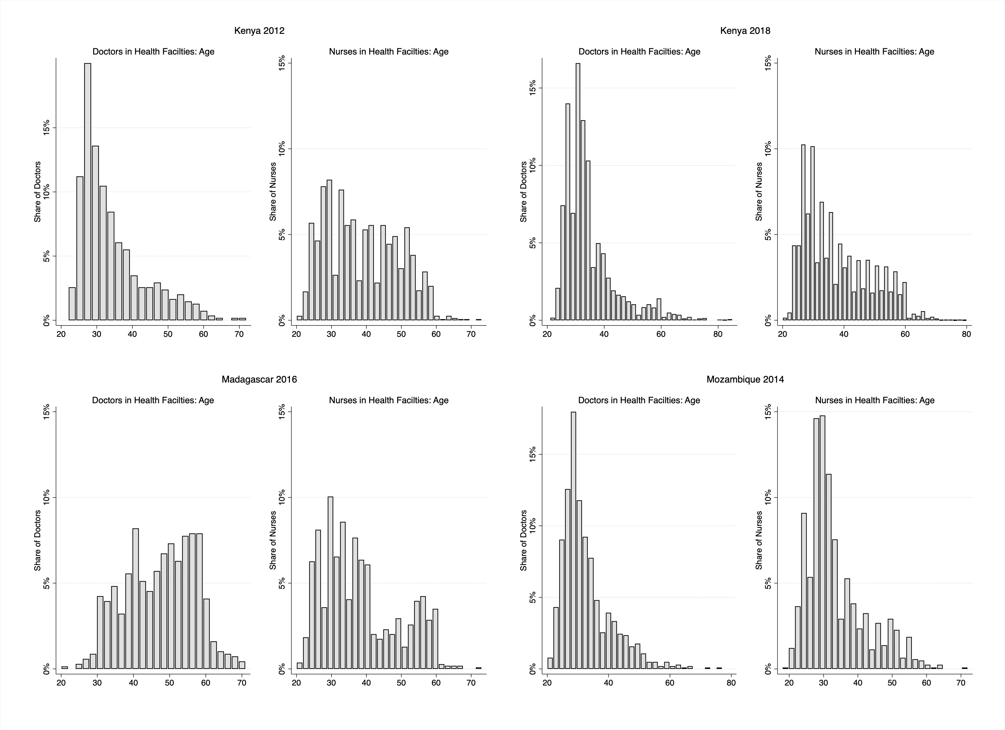

Figure 7: Age of Staff Occupation by Country

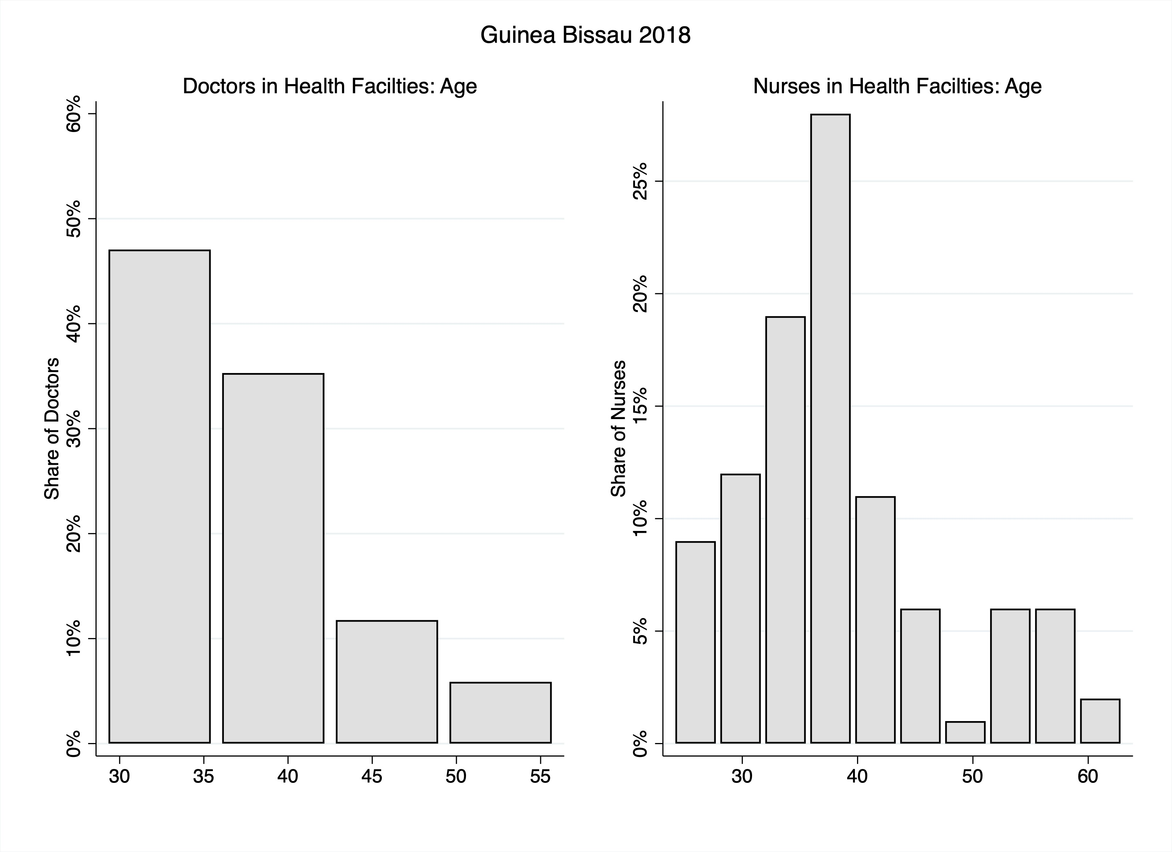

## Occupation Results

The results in this section shows the primary occupation status of all the health providers that were interviewed in each country. There are three occupation categories: doctors, nurses, and other. The other category encompasses medical (nursing) assistants, patient aides, matrons, medical aides, radiographers, physiotherapists, environmental health officers, health surveillance assistants, and pharmacists

Table 6 displays the occupation status of health providers by country.

Table 6: Provider Occupation

|  |  |  |  |  |
| --- | --- | --- | --- | --- |
|  | Doctors | Nurses | Other | All Health Providers |
|  | N | N | N | N |
|  | (%) | (%) | (%) | (%) |
| Guinea Bissau 2018 | 17 | 100 | 13 | 130 |
|  | (13.1) | (76.9) | (10.0) | (100.0) |
| Kenya 2012 | 615 | 1671 | 849 | 3135 |
|  | (19.6) | (53.3) | (27.1) | (100.0) |
| Kenya 2018 | 4408 | 11134 | 8861 | 24403 |
|  | (18.1) | (45.6) | (36.3) | (100.0) |
| Madagascar 2016 | 683 | 1084 | 433 | 2200 |
|  | (31.0) | (49.3) | (19.7) | (100.0) |
| Mozambique 2014 | 1023 | 1242 | 707 | 2972 |
|  | (34.4) | (41.8) | (23.8) | (100.0) |
| Malawi 2019 | 1228 | 4327 | 7371 | 12926 |
|  | (9.5) | (33.5) | (57.0) | (100.0) |
| Niger 2015 | 94 | 821 | 416 | 1331 |
|  | (7.1) | (61.7) | (31.3) | (100.0) |
| Nigeria 2013 | 960 | 4790 | 15445 | 21195 |
|  | (4.5) | (22.6) | (72.9) | (100.0) |
| Sierra Leone 2018 | 62 | 1553 | 3440 | 5055 |
|  | (1.2) | (30.7) | (68.1) | (100.0) |
| Togo 2014 | 142 | 483 | 739 | 1364 |
|  | (10.4) | (35.4) | (54.2) | (100.0) |
| Tanzania 2014 | 1140 | 1310 | 2009 | 4459 |
|  | (25.6) | (29.4) | (45.1) | (100.0) |
| Tanzania 2016 | 1181 | 1874 | 2090 | 5145 |
|  | (23.0) | (36.4) | (40.6) | (100.0) |
| Uganda 2013 | 381 | 1067 | 893 | 2341 |
|  | (16.3) | (45.6) | (38.1) | (100.0) |
| *N* | 11934 | 31456 | 43266 | 86656 |

Numbers in parenthesis are row percentages

Table 7 shows the occupation status of all female health providers by country Table 7: Provider Occupation - Female Providers Only

|  |  |  |  |  |  |
| --- | --- | --- | --- | --- | --- |
|  | Doctors | Nurses | Other | All Female Providers | Average Age |
|  | N | N | N | N | N |
|  | (%) | (%) | (%) | (%) | (min-max) |
| Guinea Bissau 2018 | 2 | 51 | 7 | 60 | 37.6 |
|  | (3.3) | (85.0) | (11.7) | (100.0) | (26-61) |
| Kenya 2012 | 246 | 1255 | 420 | 1921 | 37.0 |
|  | (12.8) | (65.3) | (21.9) | (100.0) | (18-73) |
| Kenya 2018 | 1583 | 7753 | 4361 | 13697 | 35.8 |
|  | (11.6) | (56.6) | (31.8) | (100.0) | (19-81) |
| Madagascar 2016 | 333 | 734 | 265 | 1332 | 40.2 |
|  | (25.0) | (55.1) | (19.9) | (100.0) | (17-69) |
| Mozambique 2014 | 370 | 761 | 274 | 1405 | 33.2 |
|  | (26.3) | (54.2) | (19.5) | (100.0) | (20-72) |
| Malawi 2019 | 220 | 2972 | 2756 | 5948 | 36.1 |
|  | (3.7) | (50.0) | (46.3) | (100.0) | (17-78) |
| Niger 2015 | 25 | 630 | 266 | 921 | 33.7 |
|  | (2.7) | (68.4) | (28.9) | (100.0) | (18-69) |
| Nigeria 2013 | 167 | 3347 | 10526 | 14040 | 39.2 |
|  | (1.2) | (23.8) | (75.0) | (100.0) | (15-77) |
| Sierra Leone 2018 | 15 | 1292 | 1712 | 3019 | 38.7 |
|  | (0.5) | (42.8) | (56.7) | (100.0) | (18-76) |
| Togo 2014 | 31 | 209 | 455 | 695 | 37.7 |
|  | (4.5) | (30.1) | (65.5) | (100.0) | (17-74) |
| Tanzania 2014 | 355 | 1067 | 1459 | 2881 | 39.4 |
|  | (12.3) | (37.0) | (50.6) | (100.0) | (19-79) |
| Tanzania 2016 | 339 | 1513 | 1546 | 3398 | 38.1 |
|  | (10.0) | (44.5) | (45.5) | (100.0) | (16-77) |
| Uganda 2013 | 102 | 831 | 549 | 1482 | 33.7 |
|  | (6.9) | (56.1) | (37.0) | (100.0) | (19-76) |
| *N* | 3788 | 22415 | 24596 | 50799 |  |

Numbers in parenthesis are row percentages

Table 8 depicts the occupation status of all male health providers by country Table 8: Provider Occupation - Male Providers Only

|  |  |  |  |  |  |
| --- | --- | --- | --- | --- | --- |
|  | Doctors | Nurses | Other | All Male Providers | Average Age |
|  | N | N | N | N | N |
|  | (%) | (%) | (%) | (%) | (min-max) |
| Guinea Bissau 2018 | 15 | 49 | 6 | 70 | 37.9 |
|  | (21.4) | (70.0) | (8.6) | (100.0) | (24-63) |
| Kenya 2012 | 369 | 416 | 422 | 1207 | 36.9 |
|  | (30.6) | (34.5) | (35.0) | (100.0) | (21-68) |
| Kenya 2018 | 2825 | 3381 | 4500 | 10706 | 36.1 |
|  | (26.4) | (31.6) | (42.0) | (100.0) | (19-85) |
| Madagascar 2016 | 350 | 350 | 168 | 868 | 44.1 |
|  | (40.3) | (40.3) | (19.4) | (100.0) | (20-73) |
| Mozambique 2014 | 653 | 481 | 433 | 1567 | 33.2 |
|  | (41.7) | (30.7) | (27.6) | (100.0) | (18-77) |
| Malawi 2019 | 1007 | 1350 | 4574 | 6931 | 37.9 |
|  | (14.5) | (19.5) | (66.0) | (100.0) | (15-86) |
| Niger 2015 | 67 | 189 | 150 | 406 | 38.7 |
|  | (16.5) | (46.6) | (36.9) | (100.0) | (19-72) |
| Nigeria 2013 | 793 | 1443 | 4914 | 7150 | 40.2 |
|  | (11.1) | (20.2) | (68.7) | (100.0) | (19-82) |
| Sierra Leone 2018 | 47 | 261 | 1728 | 2036 | 38.1 |
|  | (2.3) | (12.8) | (84.9) | (100.0) | (16-75) |
| Togo 2014 | 111 | 274 | 284 | 669 | 40.0 |
|  | (16.6) | (41.0) | (42.5) | (100.0) | (22-69) |
| Tanzania 2014 | 785 | 243 | 550 | 1578 | 41.1 |
|  | (49.7) | (15.4) | (34.9) | (100.0) | (20-85) |
| Tanzania 2016 | 842 | 354 | 536 | 1732 | 39.3 |
|  | (48.6) | (20.4) | (30.9) | (100.0) | (15-77) |
| Uganda 2013 | 279 | 236 | 343 | 858 | 34.2 |
|  | (32.5) | (27.5) | (40.0) | (100.0) | (19-75) |
| *N* | 8143 | 9027 | 18608 | 35778 |  |

Numbers in parenthesis are row percentages

Figure 8 indicates the leading occupation status by country.

Figure 8: Staff Occupation by Country

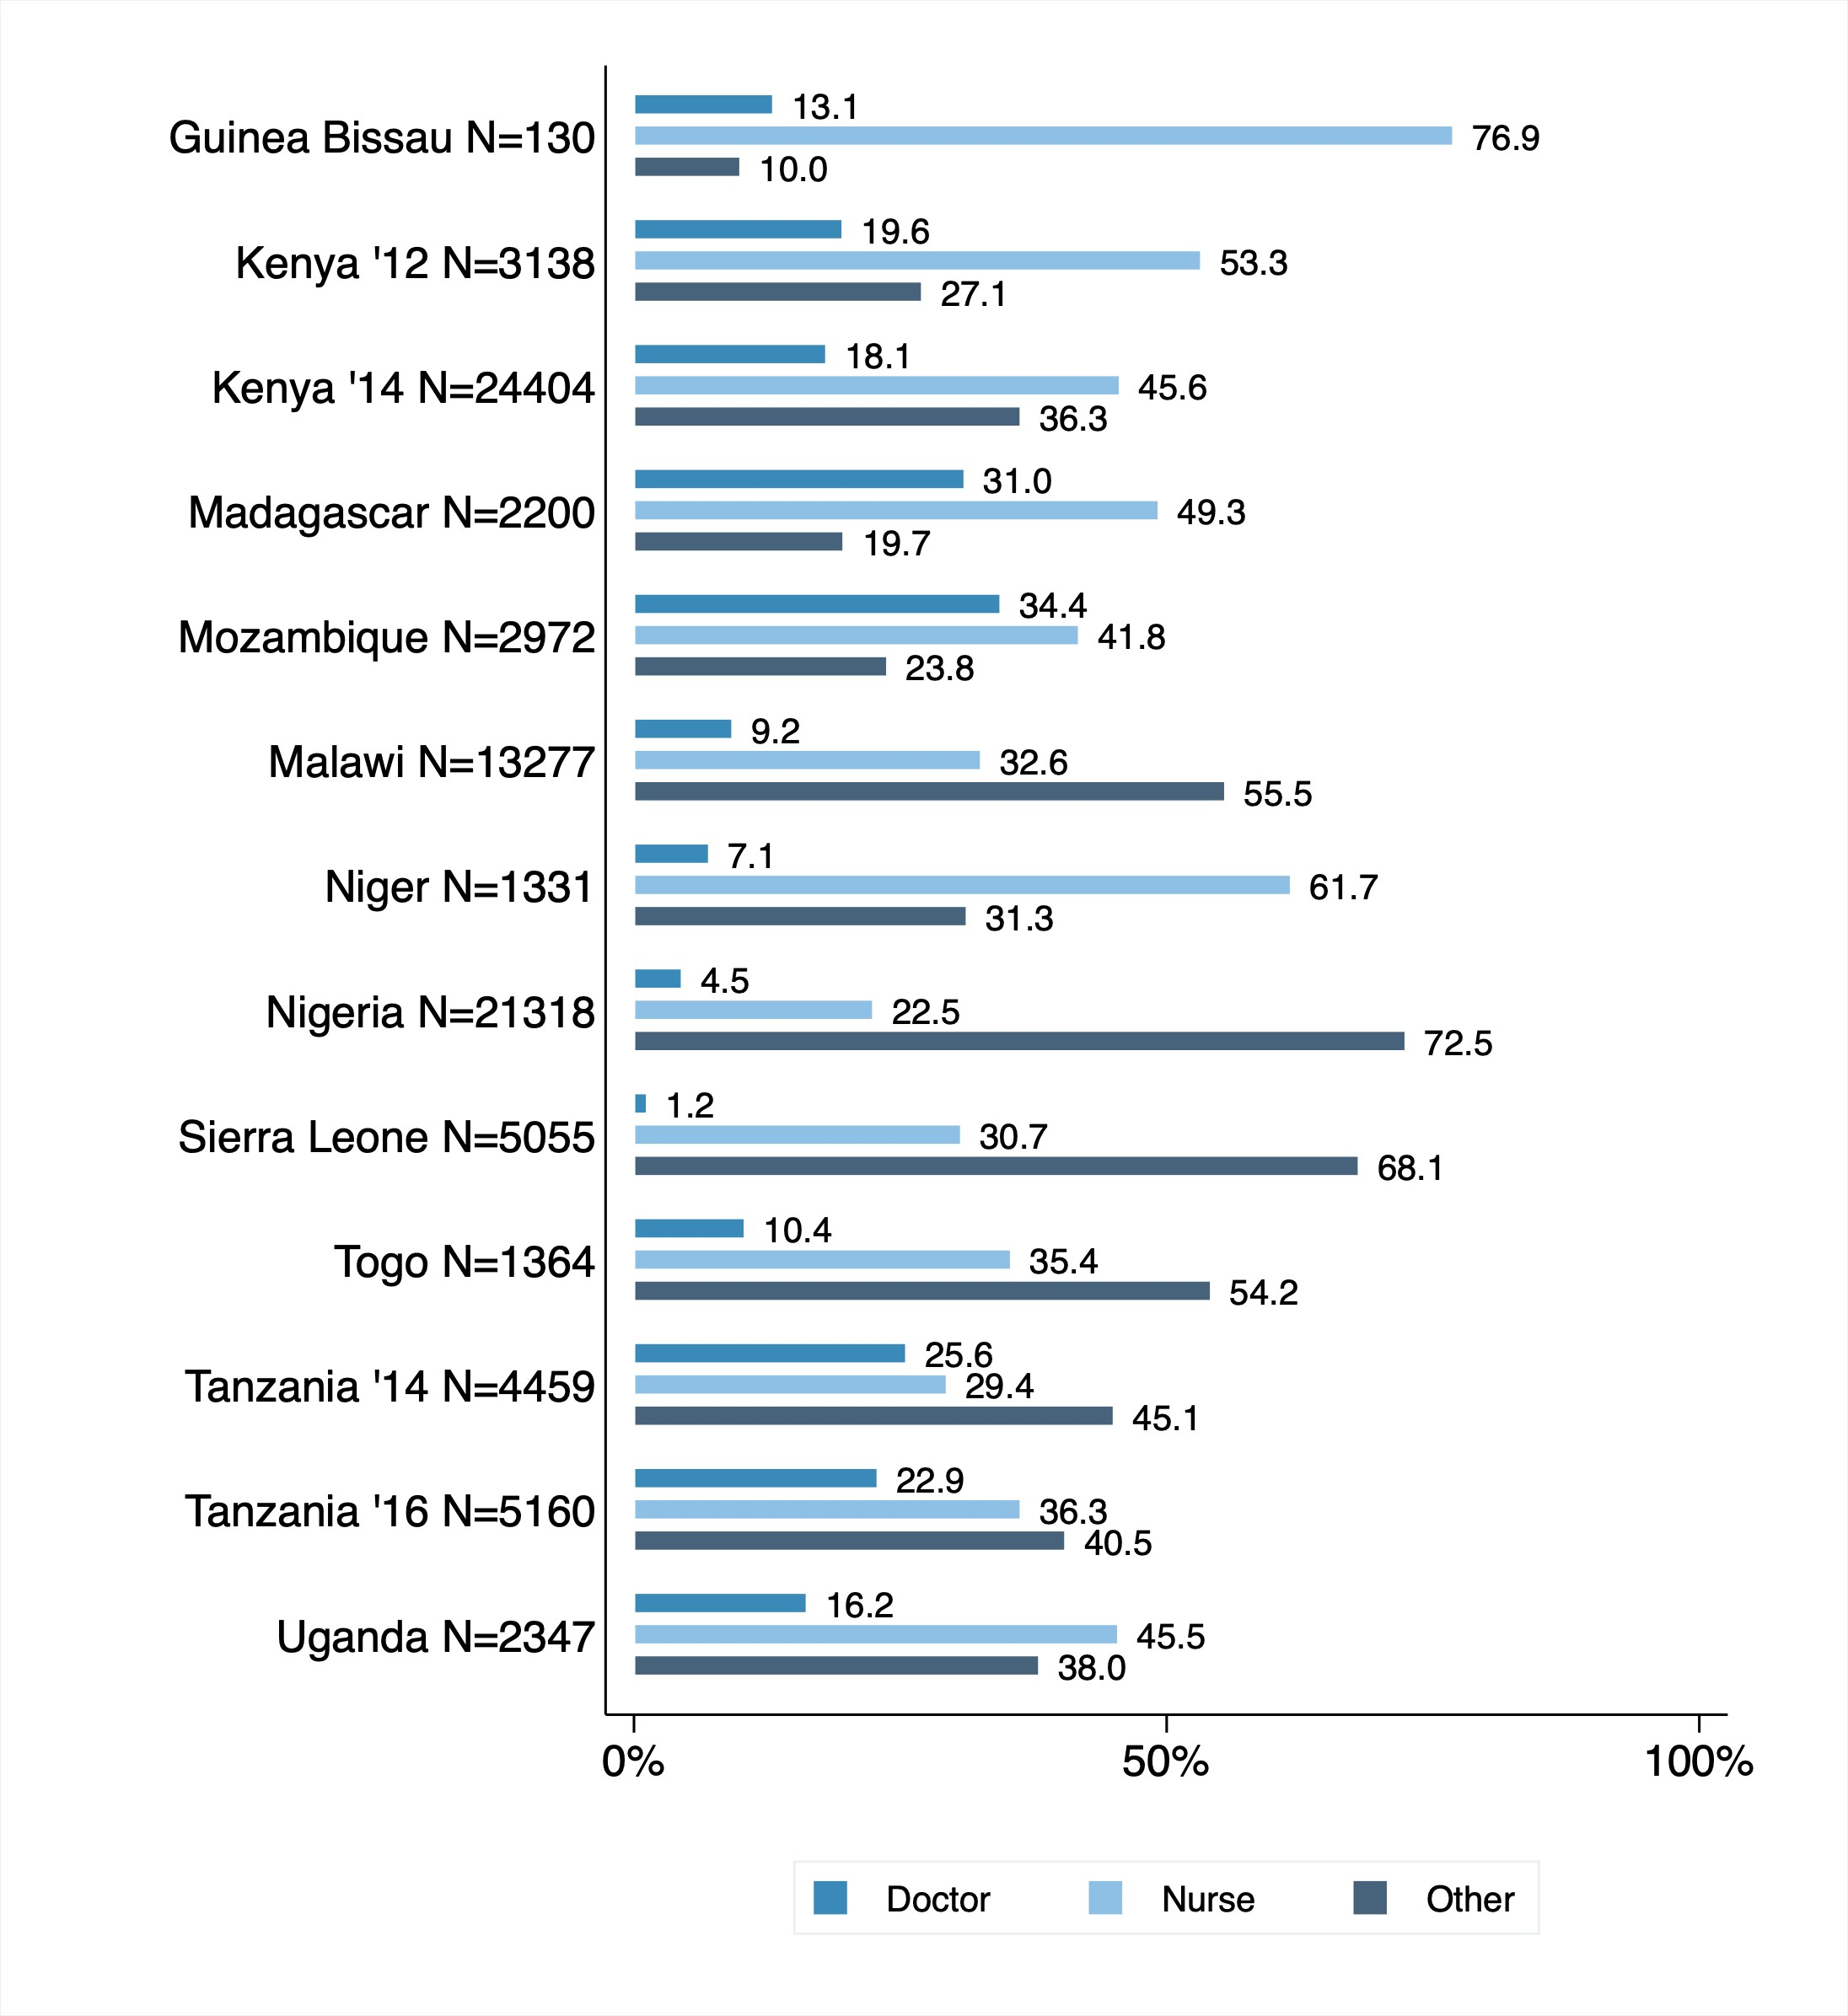

Figure 9 depicts the occupation status of health providers by region within each country.

Figure 9: Staff Occupation by Region

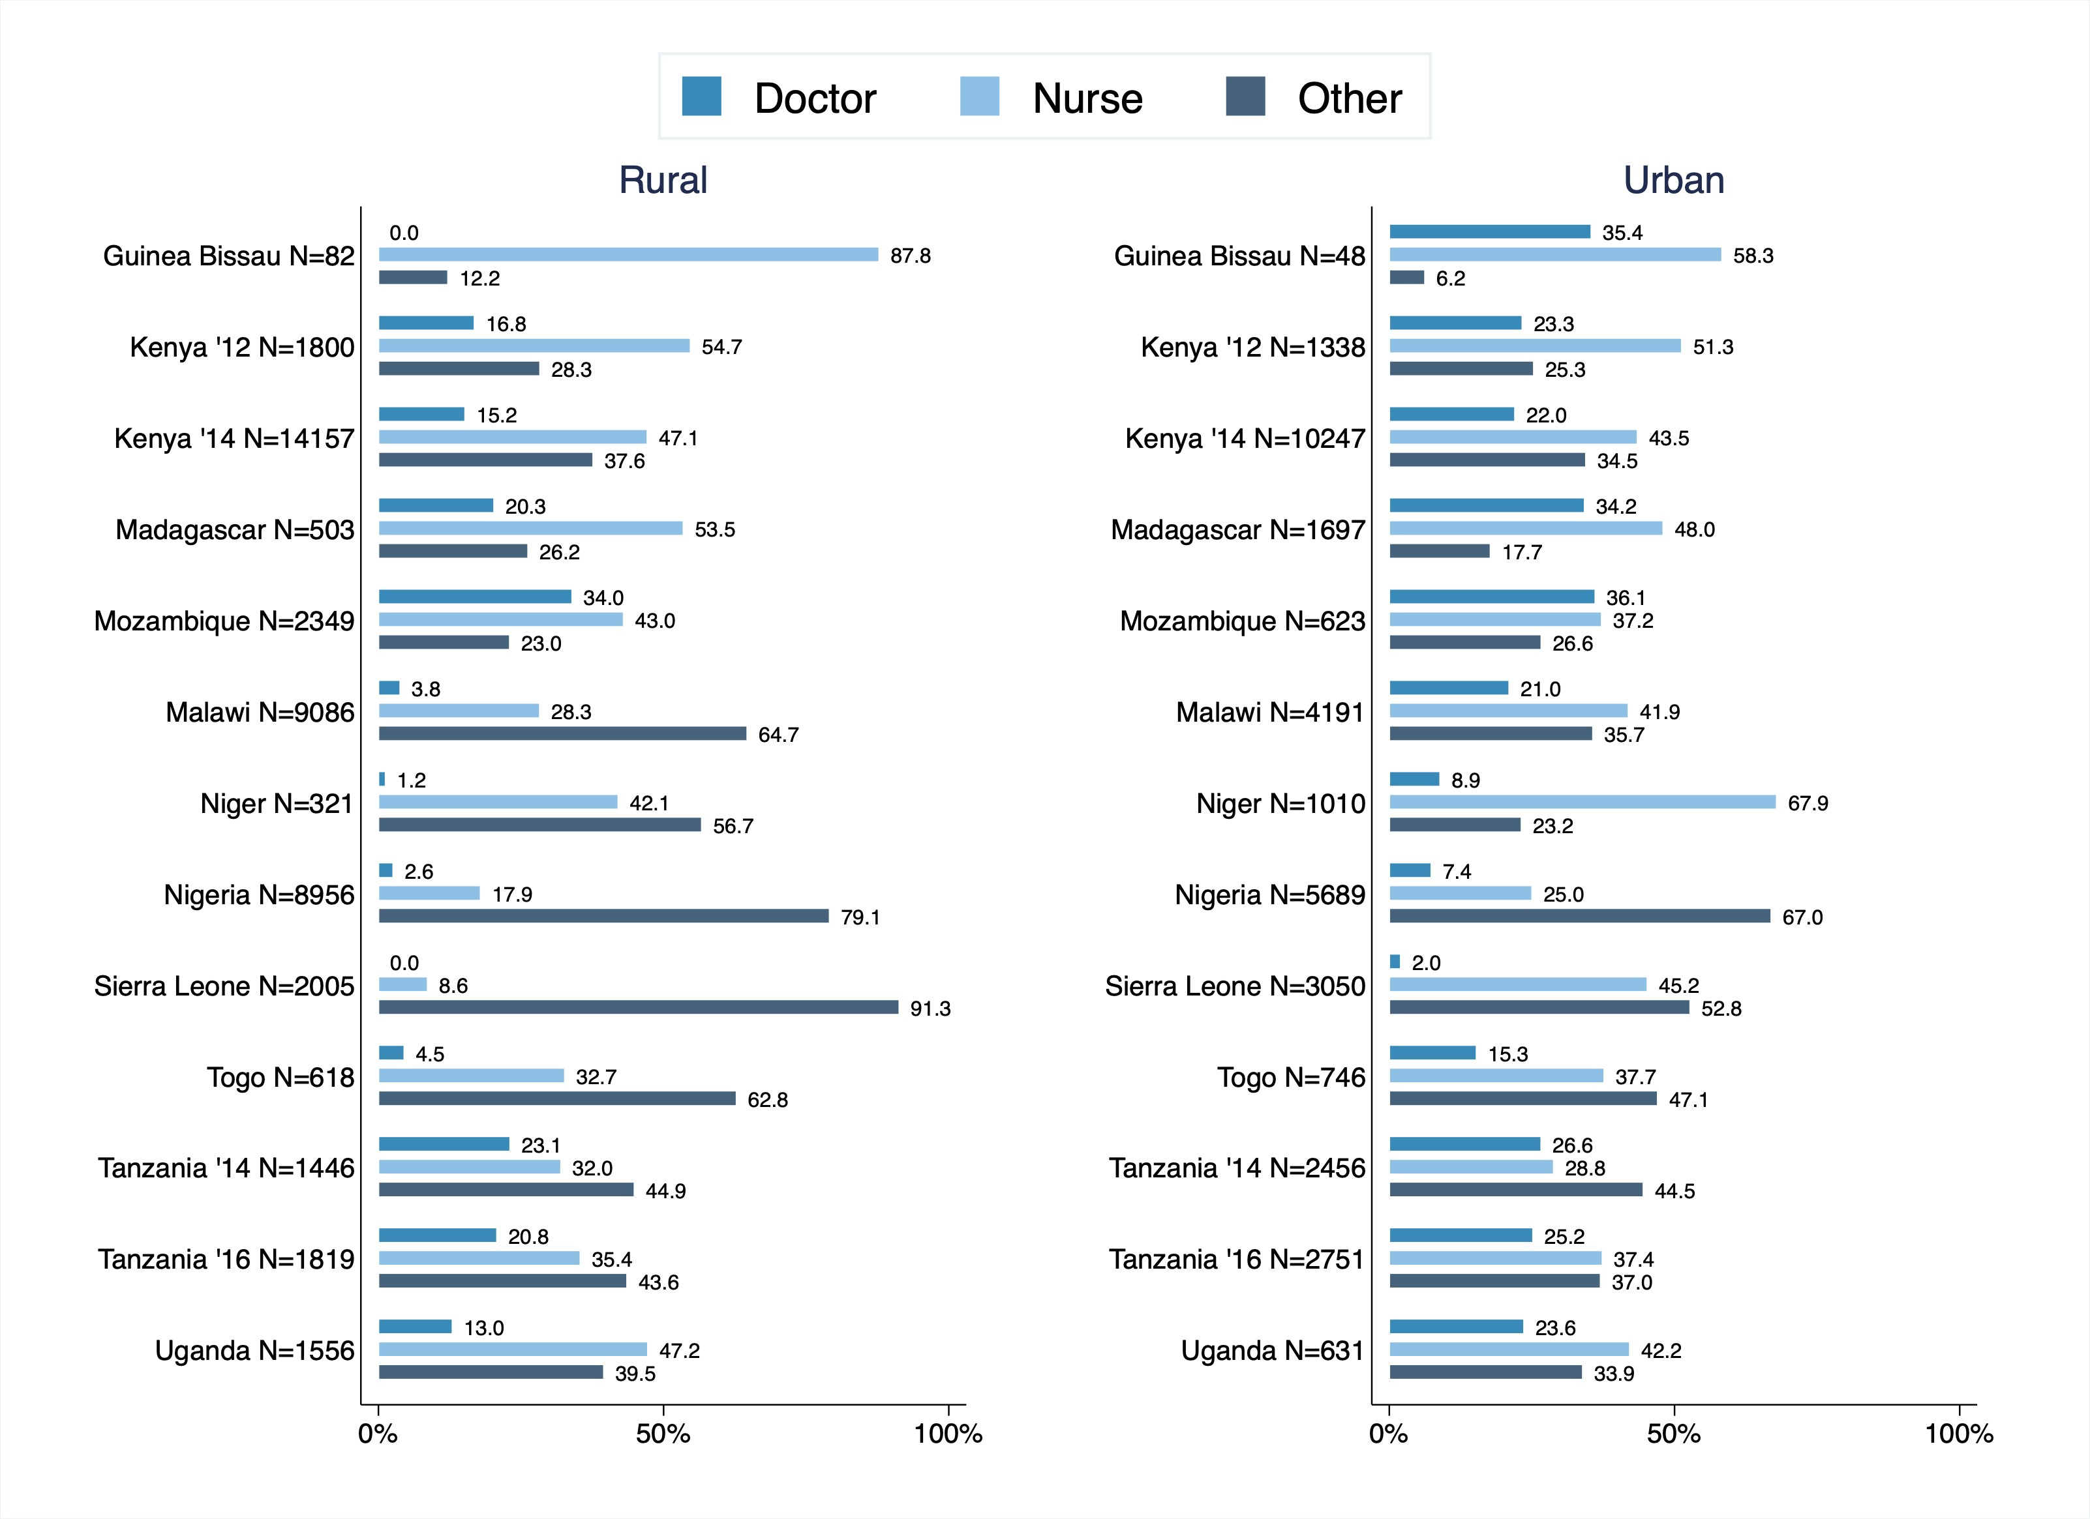

Figure 10 depicts the occupation status of health providers by region within each country.

Figure 10: Staff Occupation by Facility Type

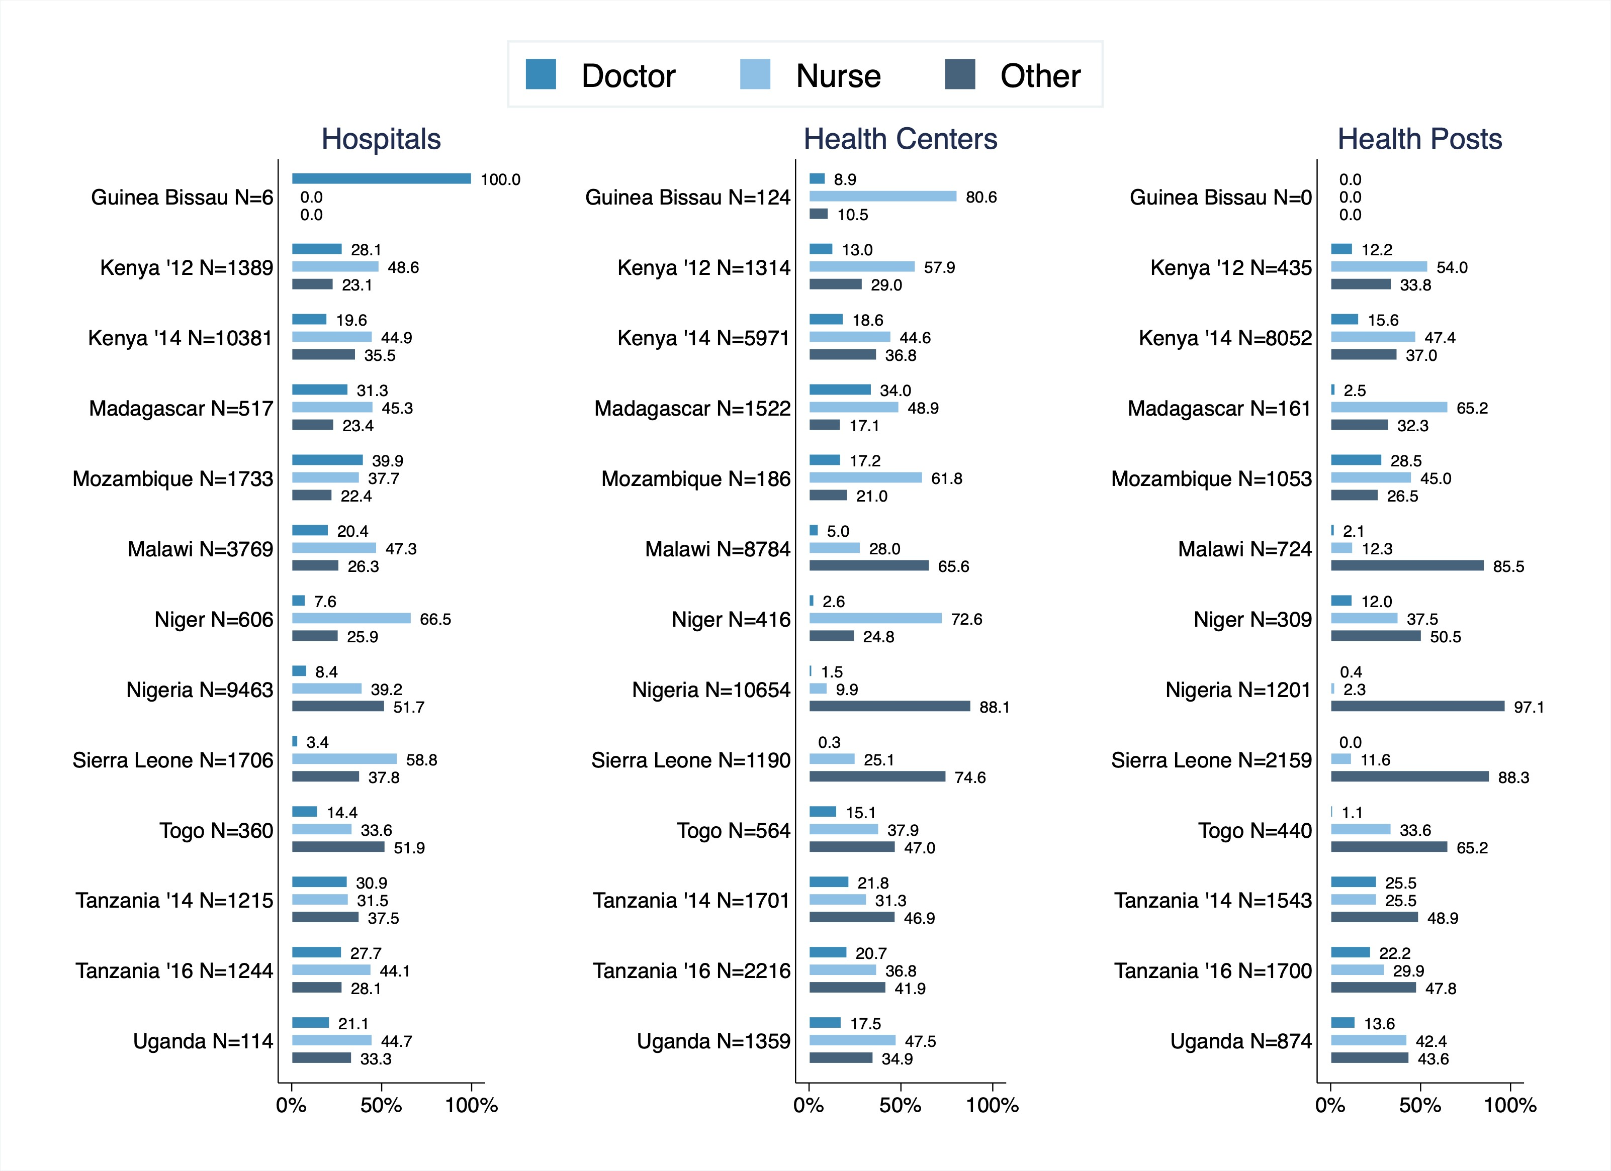

# Poverty Rate Estimates

Figure 11: Share of Clinics that have a Medical Officer

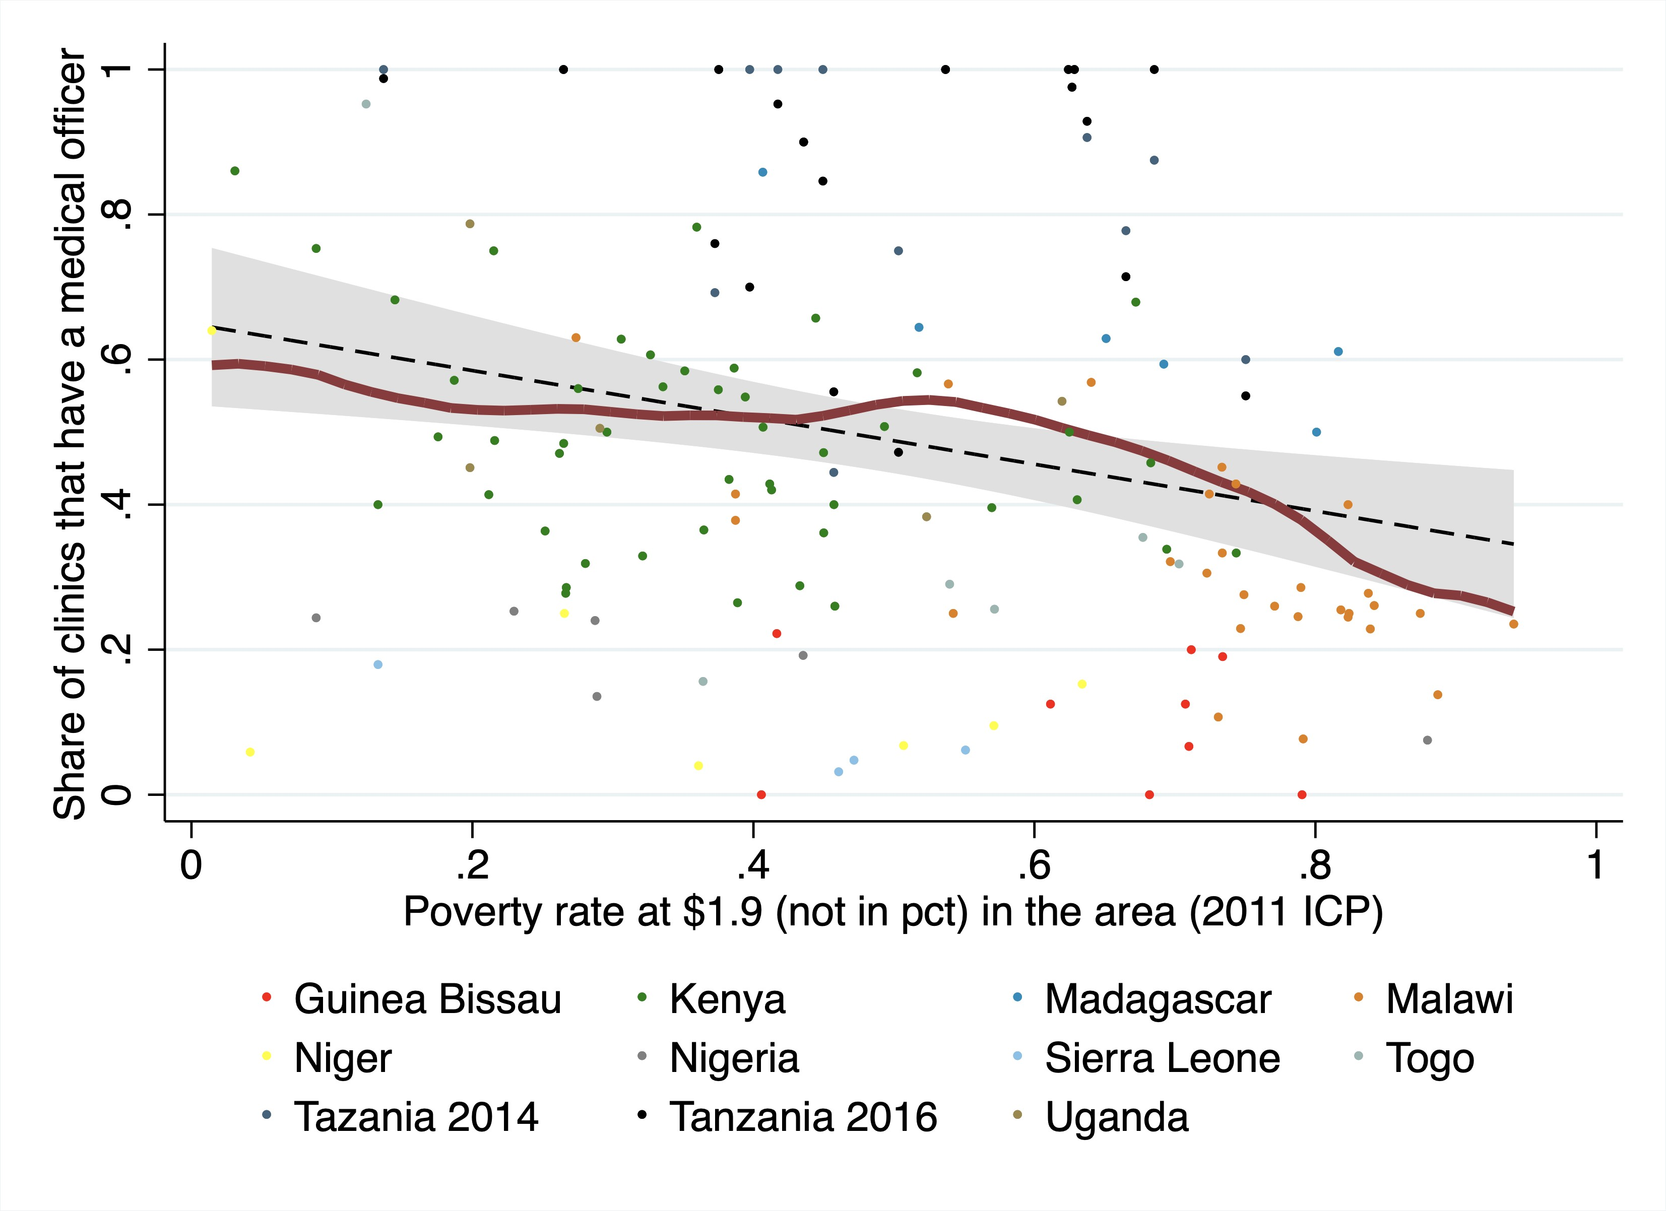

Figure 12: Share of Clinics that have a Medical Officer by Region

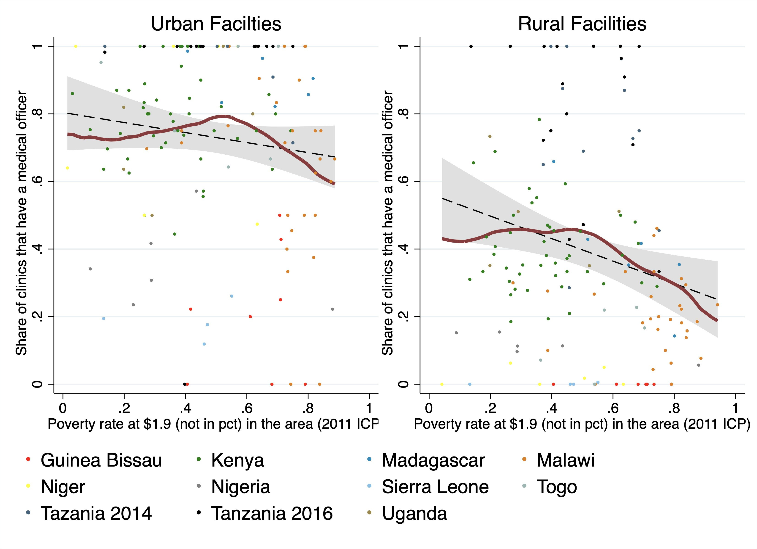

The figures below indicate the correlation between poverty rate and the share of clinics that have a medical officer.

Figure 13: Share of Clinics that have a Medical Officer by Country

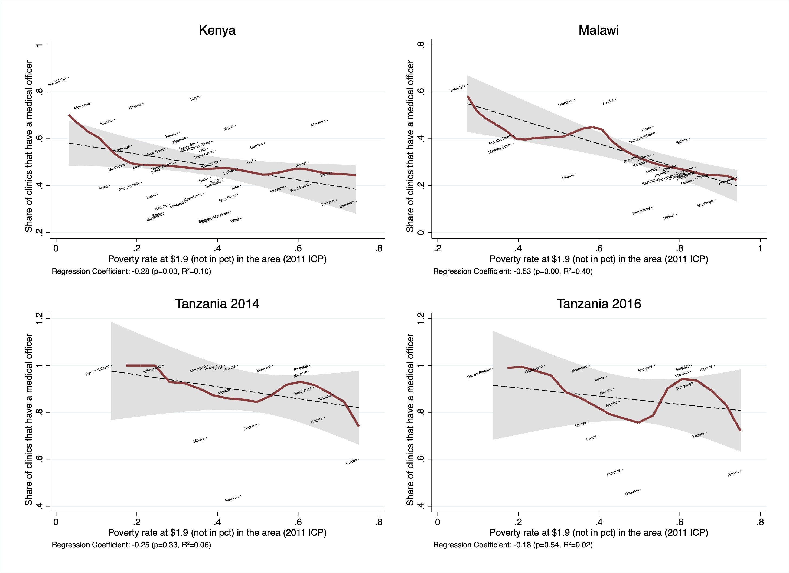

Figure 14: Share of Clinics that have a Medical Officer by Country

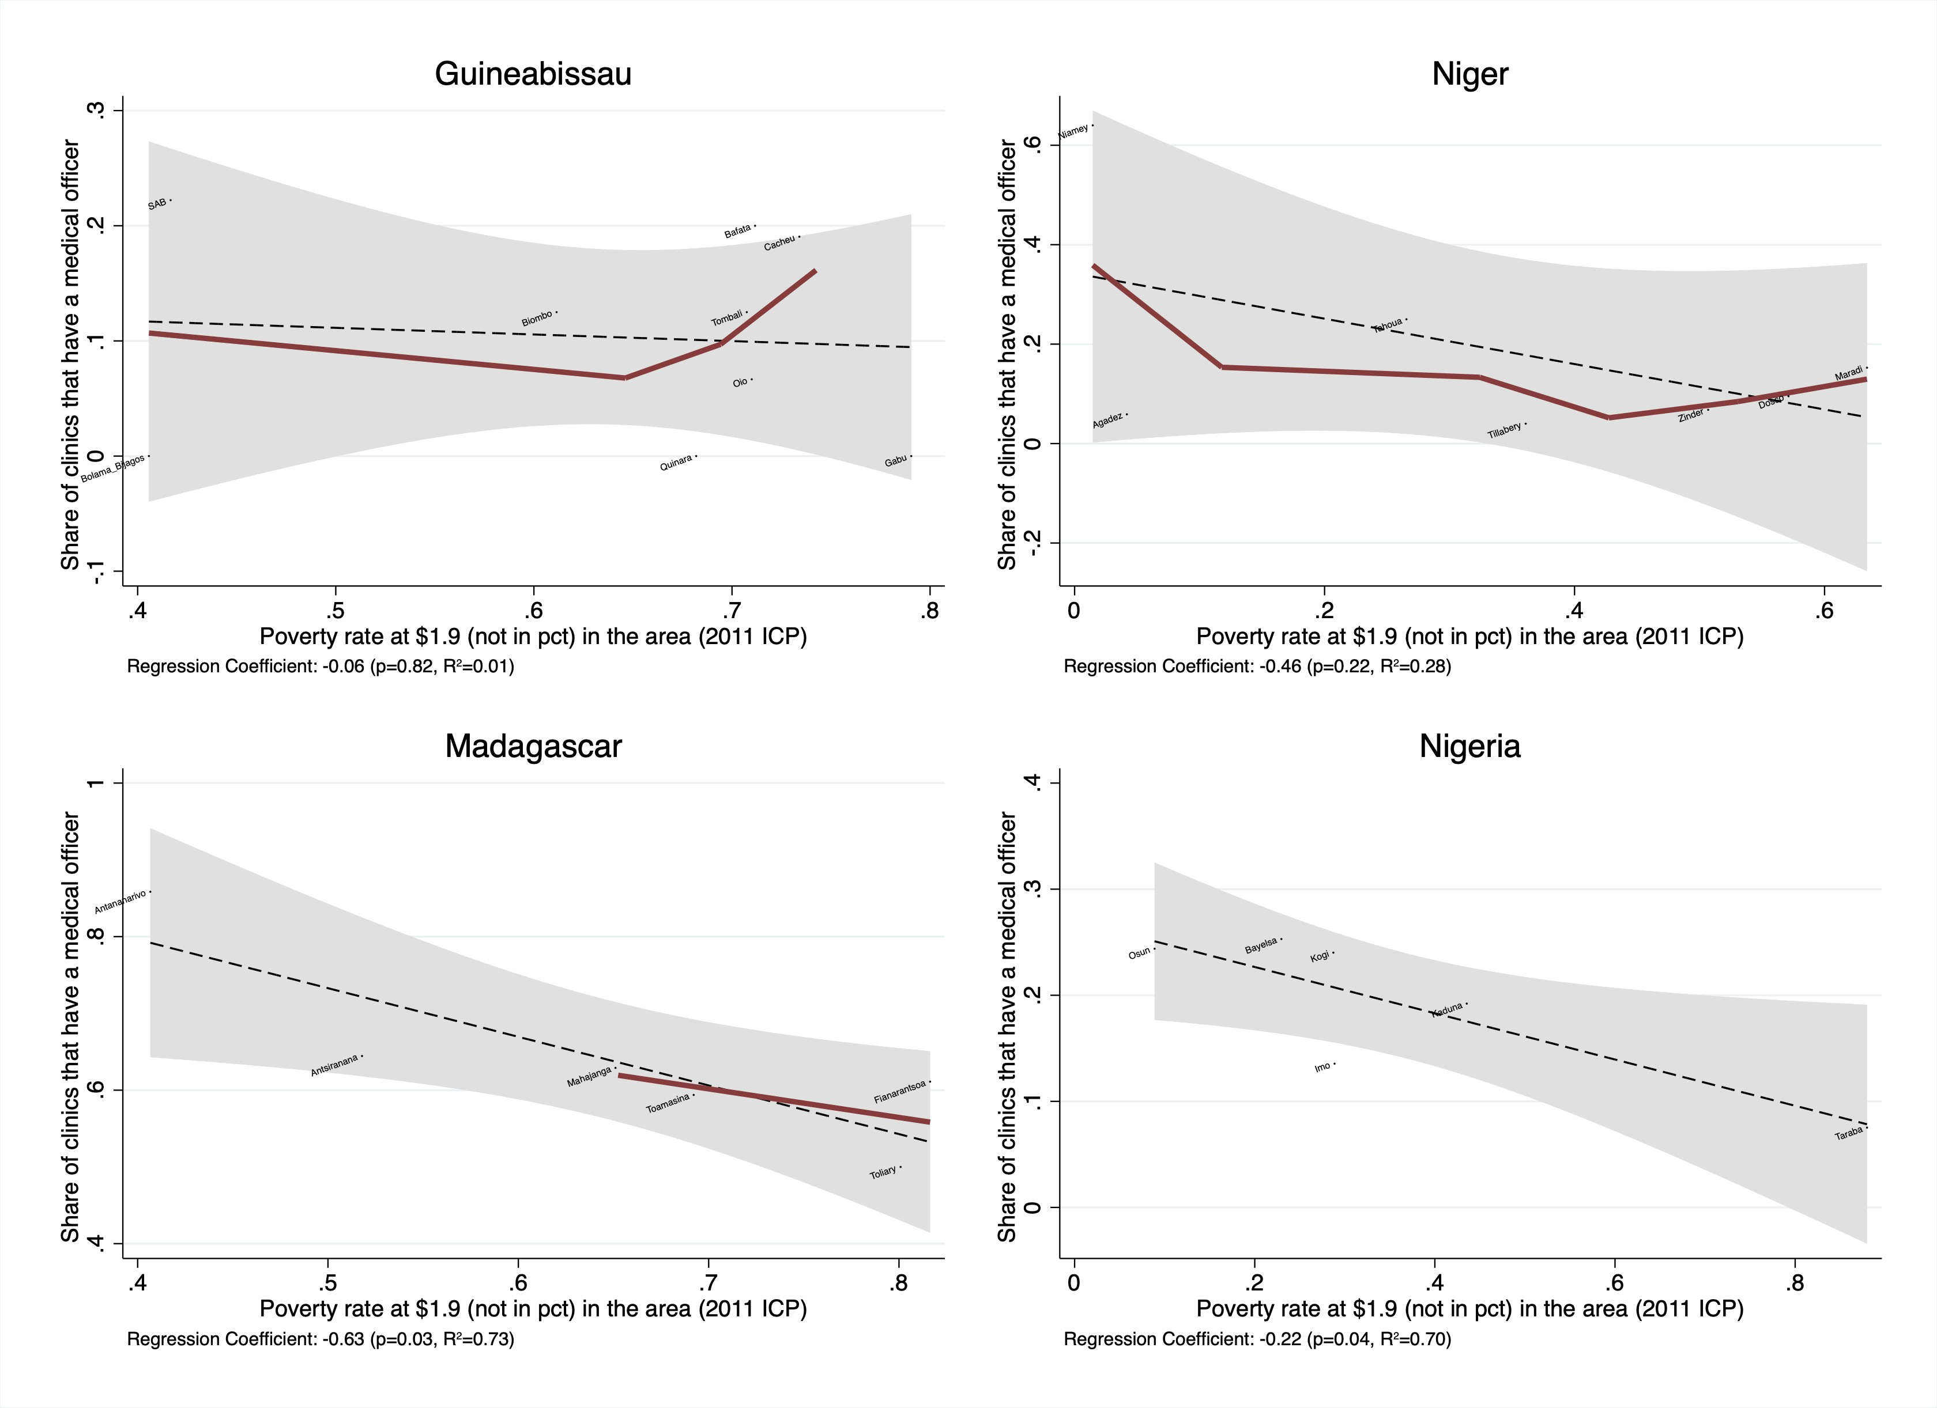

Figure 15: Share of Clinics that have a Medical Officer by Country

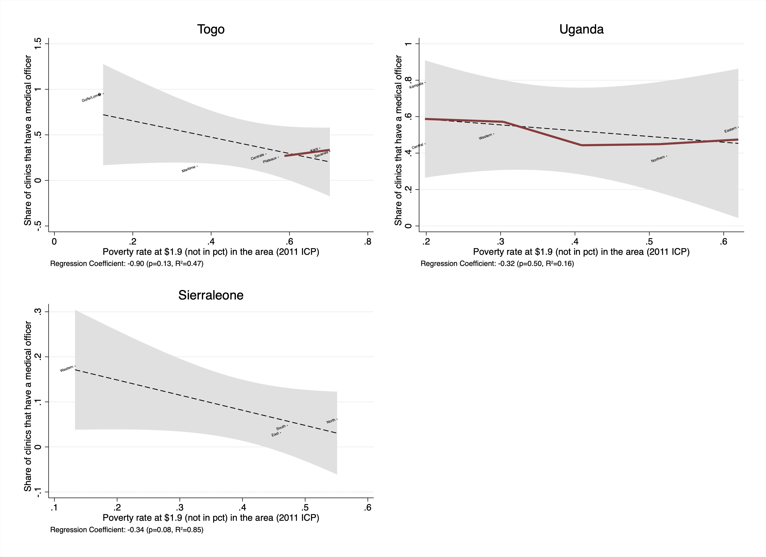

The figures below indicate the correlation between poverty rate and the share of clinics that have a nurse or paramedical staff.

Figure 16: Share of Clinics that have a Nurse by Country

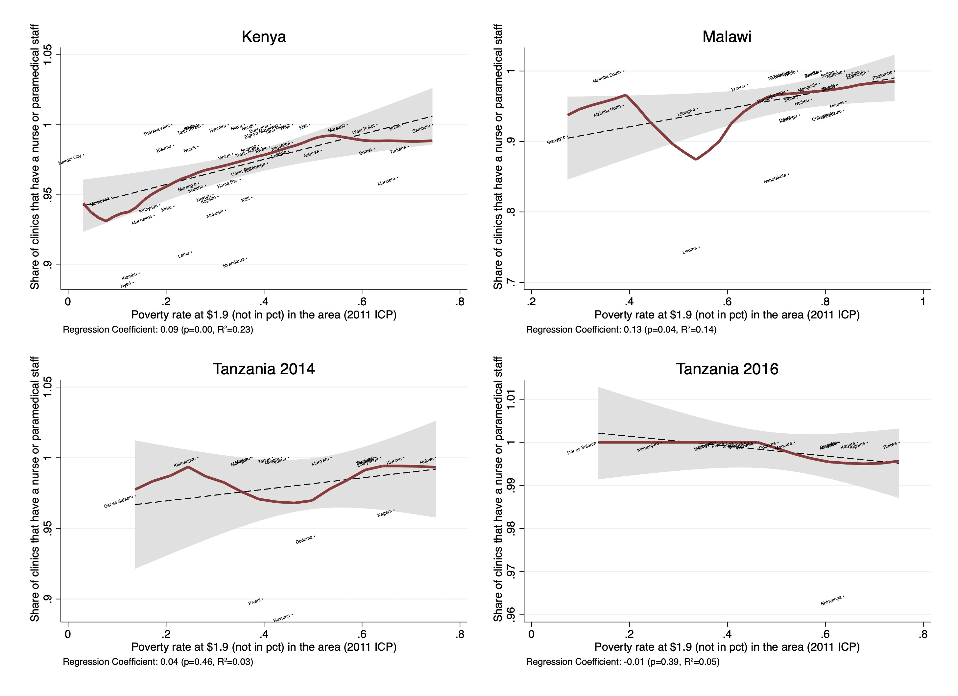

Figure 17: Share of Clinics that have a Nurse by Country

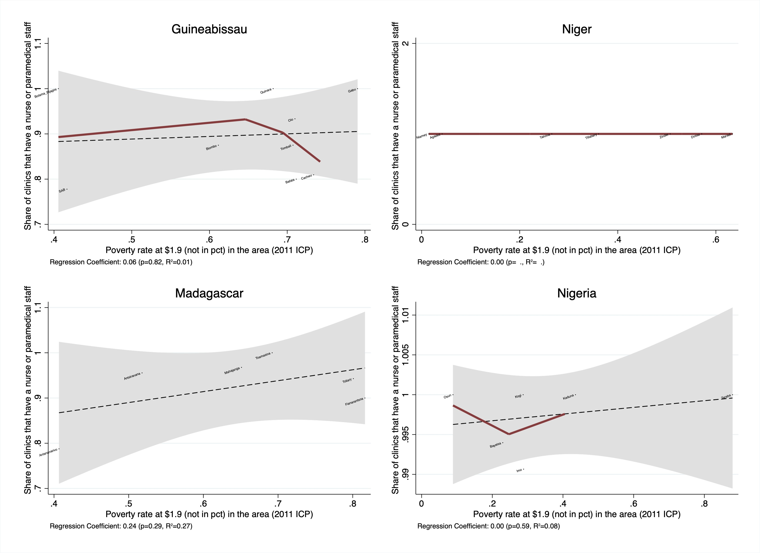

Figure 18: Share of Clinics that have a Nurse by Country

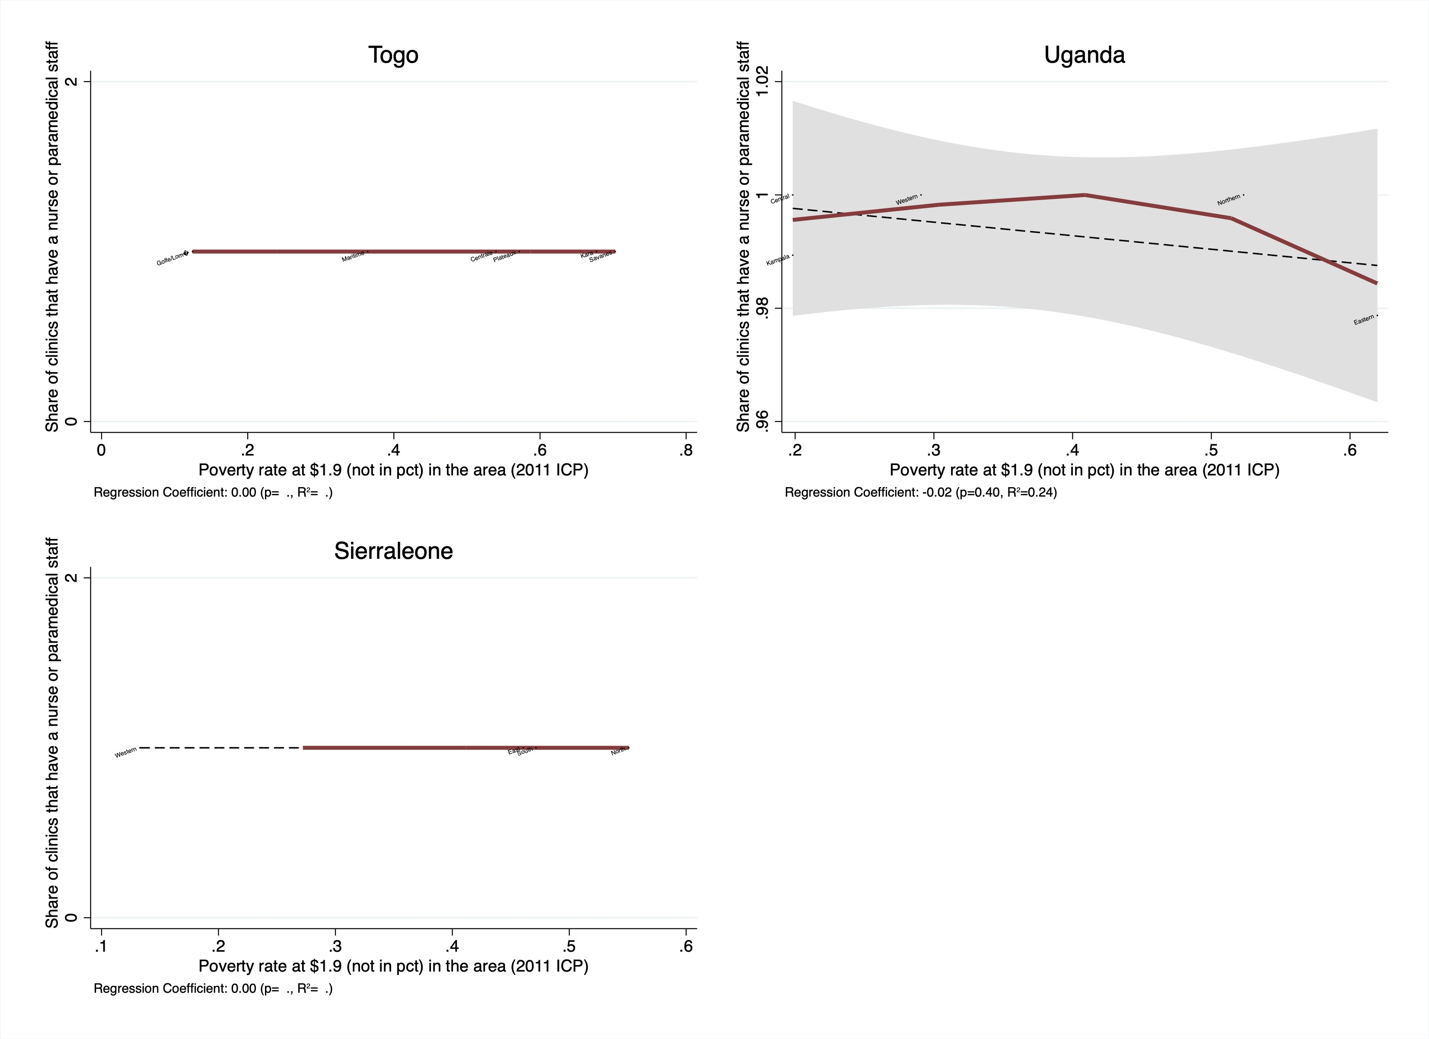

The figures below indicate the correlation between poverty rate and the share of medical providers per facility in each country.

Figure 19: Share of Medical Providers by Country

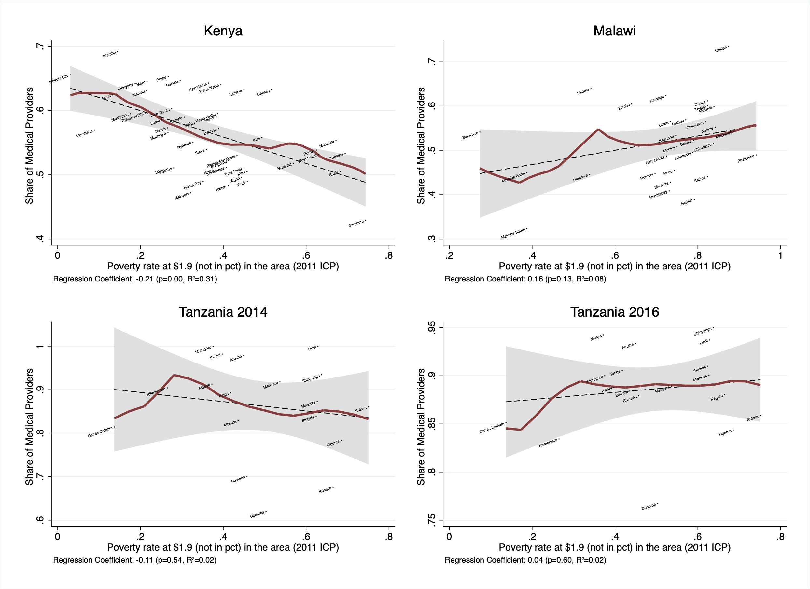

Figure 20: Share of Medical Providers by Country

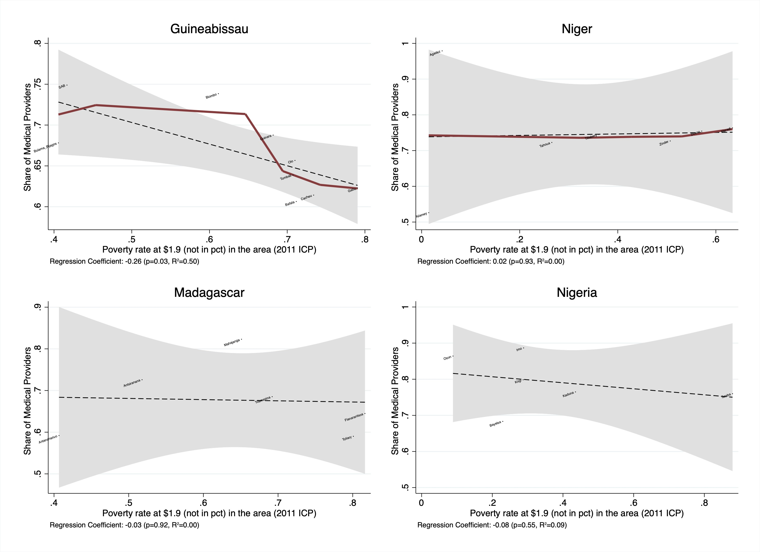

Figure 21: Share of Medical Providers by Country

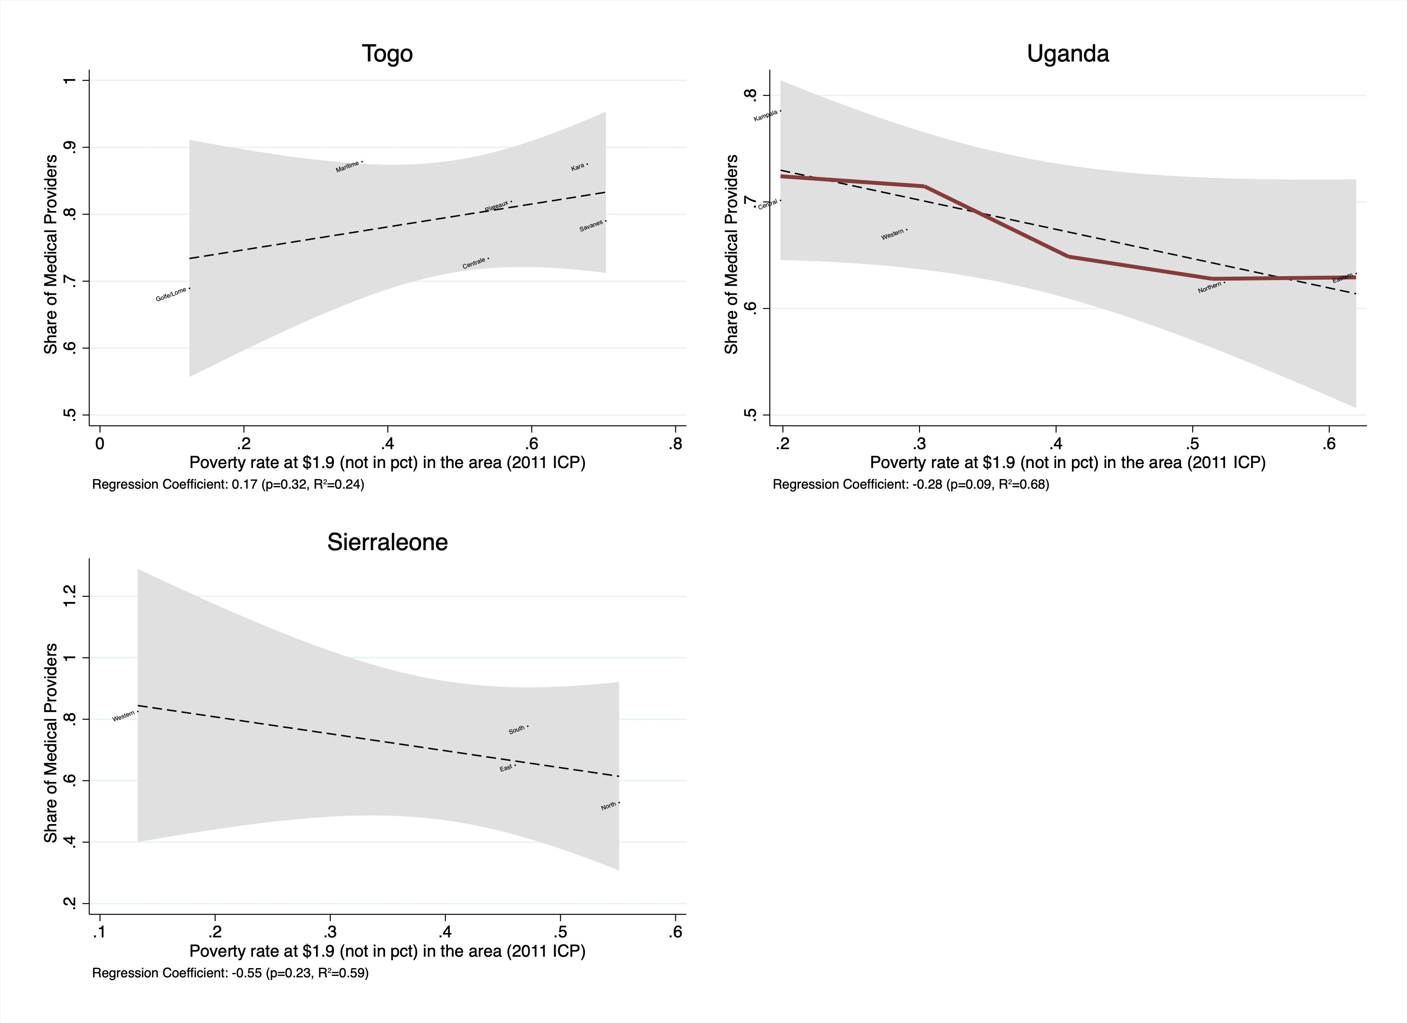

The figures below indicate the correlation between poverty rate and the share of medical officers per facility in each country.

Figure 22: Share of Medical Officers by Country

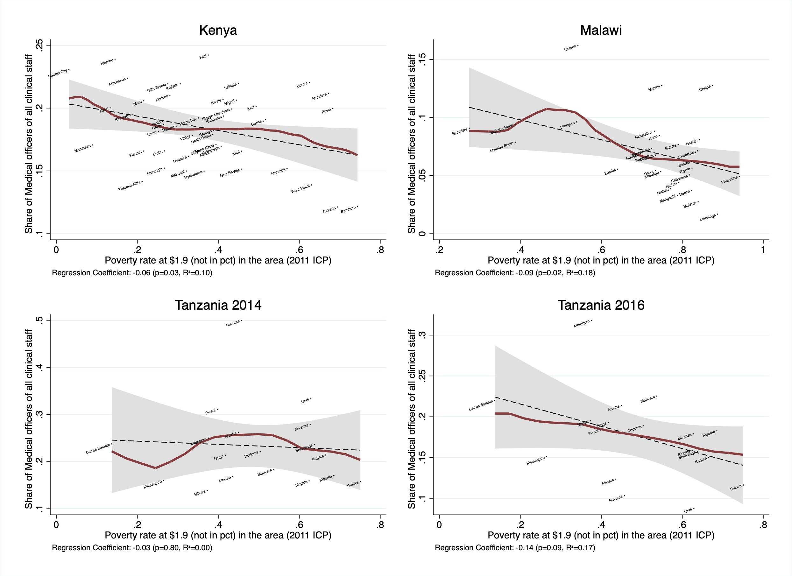

Figure 23: Share of Medical Officers by Country

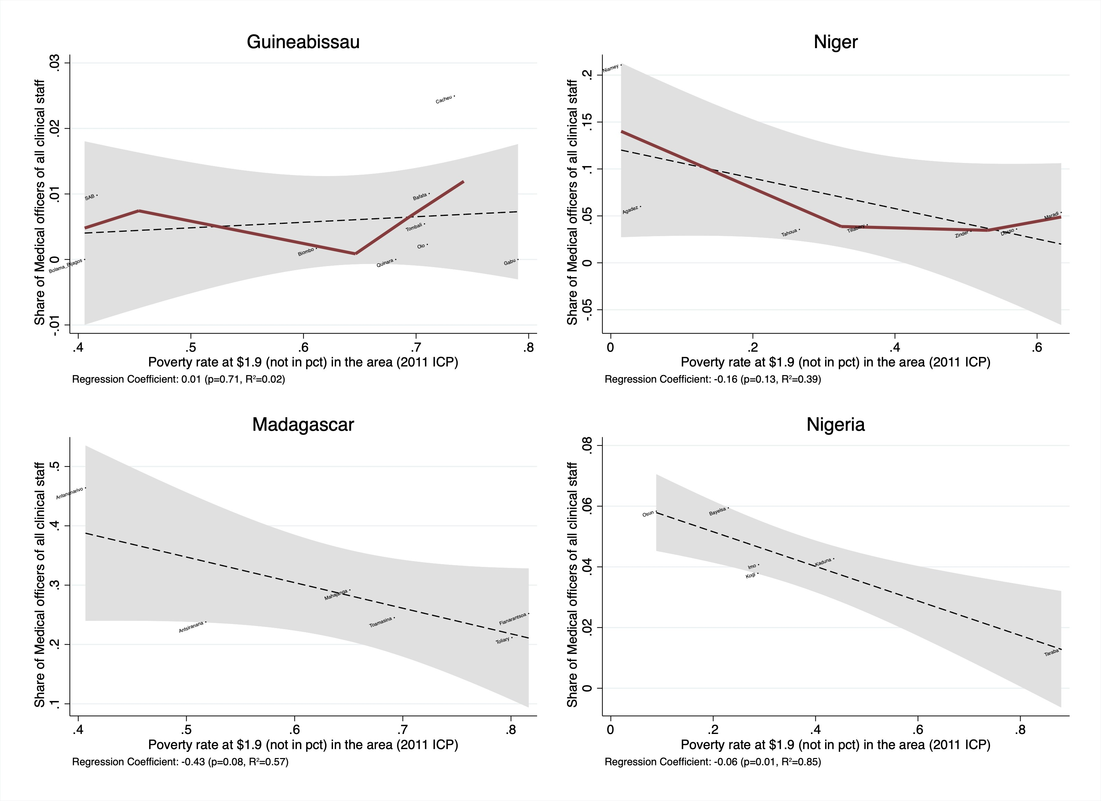

Figure 24: Share of Medical Officers by Country

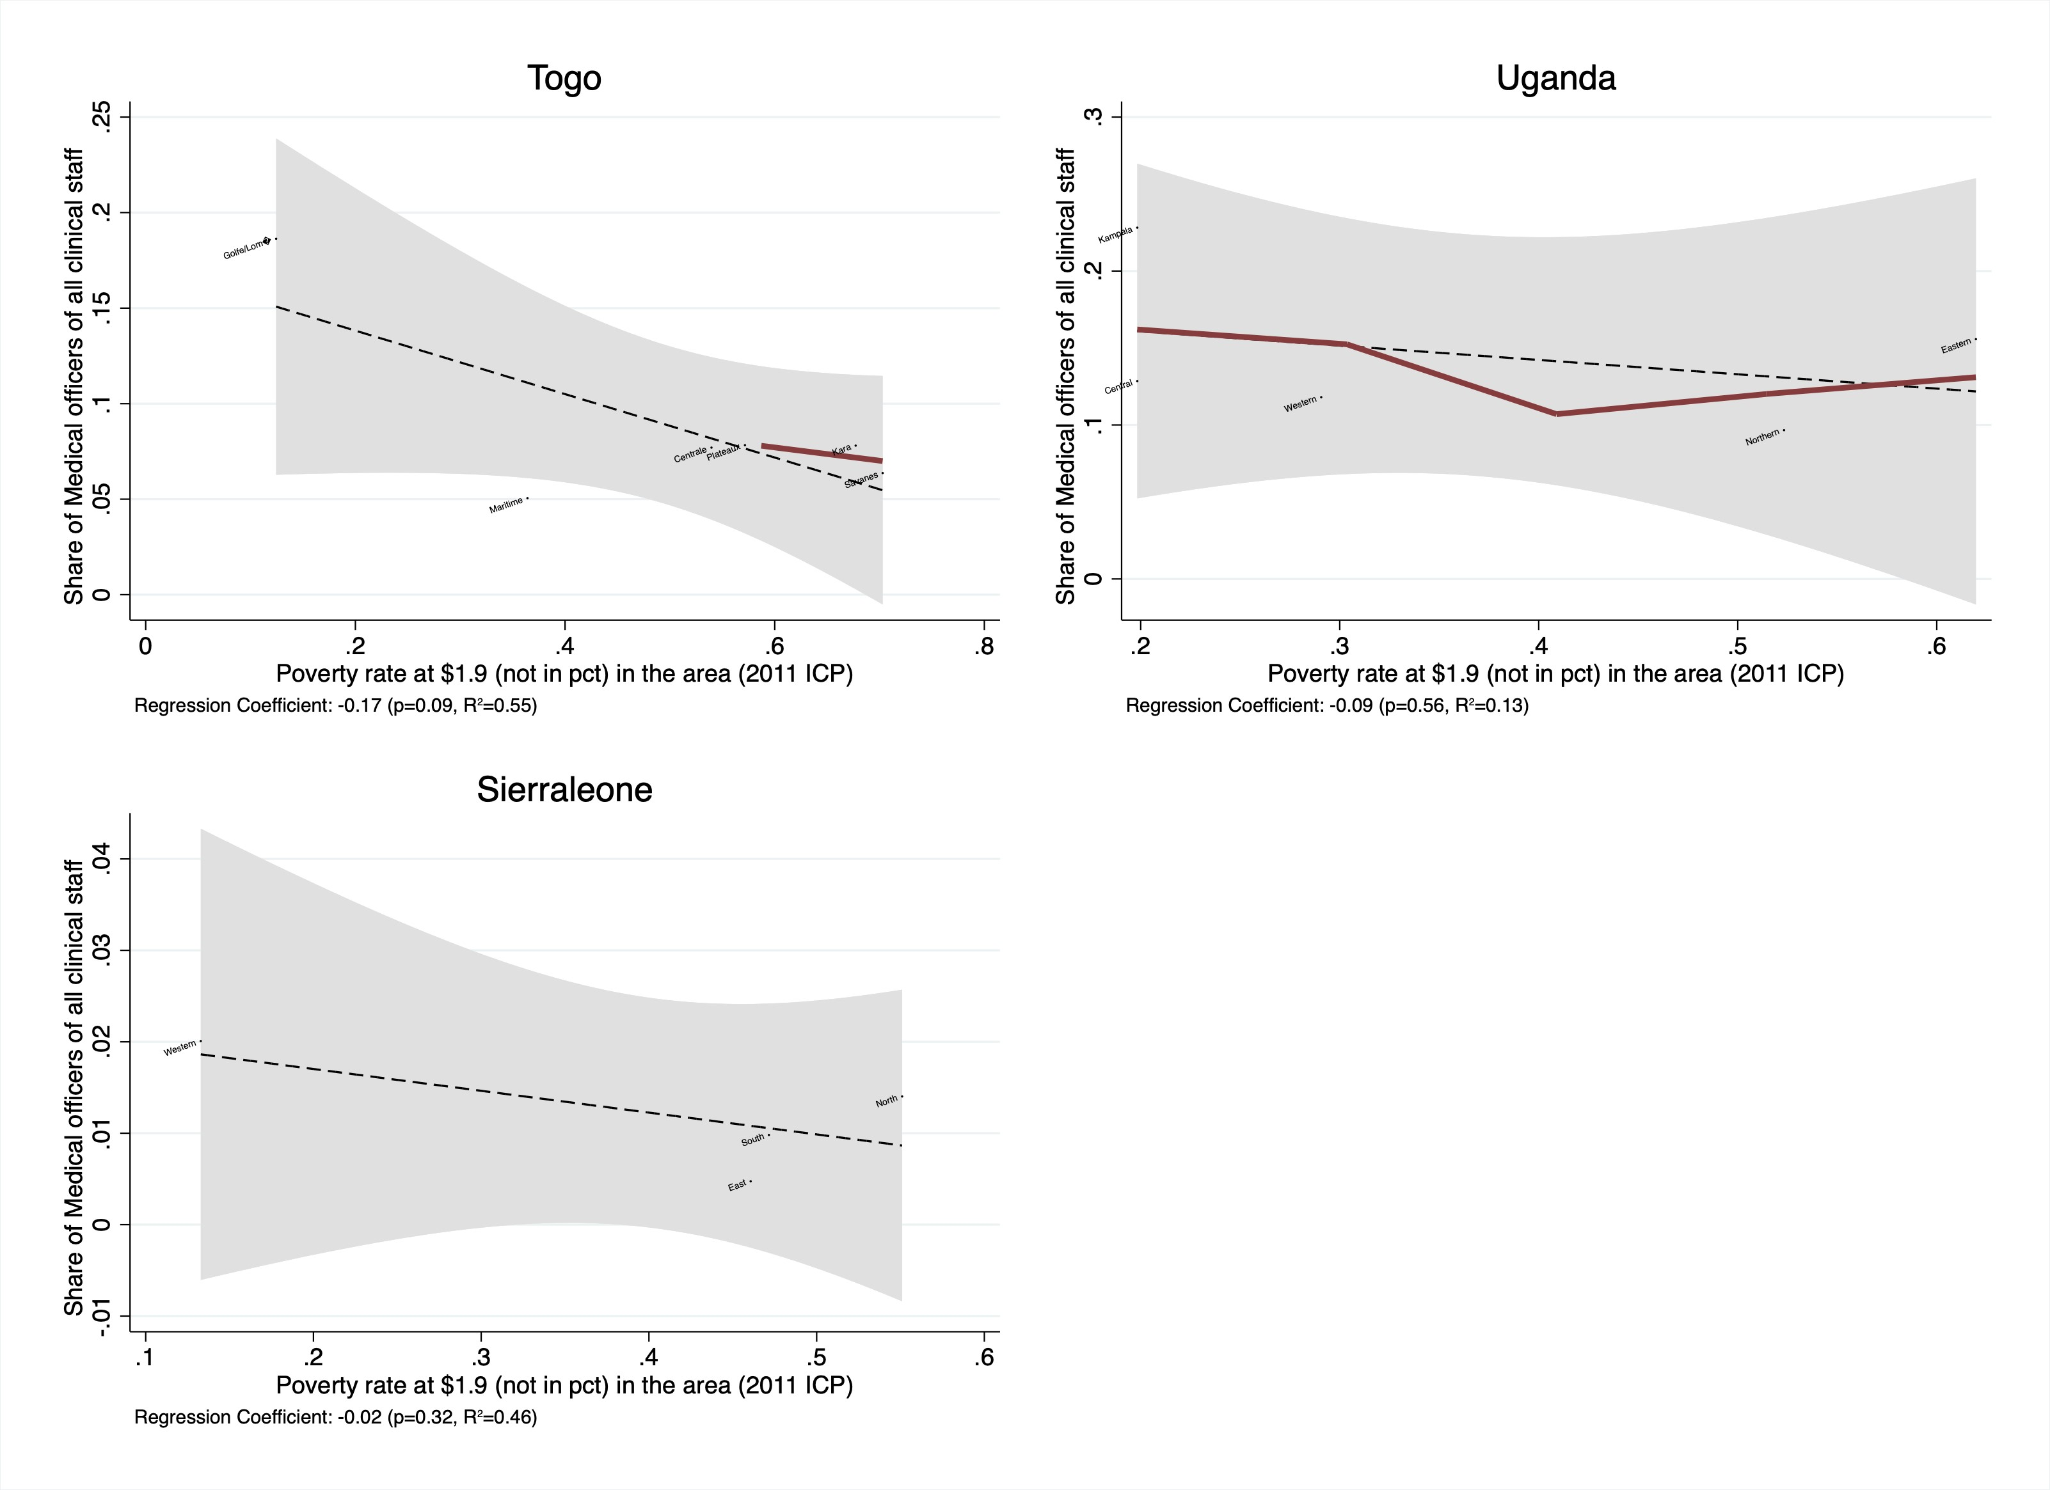

## Regression Estimates

The regression tables below report the OLS regression estimates of poverty rate at the $1.9 rate on the share of health facilities that have a medical officer in a given health facility.

Table 9: Regression Estimates of Poverty Rate on Share of Health Facilities with a Medical Officer - All Countries

|  |  |  |  |  |
| --- | --- | --- | --- | --- |
|  | (1) | (2) | (3) | (4) |
|  | Simple | Fixed Effects | Rural/Urban | All Effects |
| Poverty rate at 1.9 | -0.172** | -0.101 | -0.183*** | -0.047 |
|  | (0.068) | (0.067) | (0.060) | (0.061) |
| Hospitals |  |  | 0.318*** | 0.349*** |
|  |  |  | (0.024) | (0.023) |
| Urban/Rural Facilities (1=Rural) |  |  | -0.186*** | -0.206*** |
|  |  |  | (0.026) | (0.021) |
| Observations | 744 | 744 | 682 | 682 |
| R-squared | 0.01 | 0.27 | 0.24 | 0.51 |

Table 10: Regression Estimates of Poverty Rate on Share of Health Facilities with a Medical Officer

|  |  |  |
| --- | --- | --- |
| (1) | | (2) |
| Simple | | Rural/Urban |
| **Guinea Bissau**  Poverty rate at 1.9 0.451 | | -0.165 |
|  | (0.469) | (0.374) |
| Hospitals |  | 0.698***  (0.165) |
| Urban/Rural Facilities (1=Rural) |  | -0.142**  (0.068) |
| Observations | 23 | 23 |
| R-squared | 0.02 | 0.71 |
| **Kenya**  Poverty rate at 1.9 | -0.004 | 0.089 |
|  | (0.124) | (0.113) |
| Hospitals |  | 0.216***  (0.035) |
| Urban/Rural Facilities (1=Rural) |  | -0.229***  (0.032) |
| Observations | 249 | 249 |
| R-squared | 0.00 | 0.25 |
| **Madagascar**  Poverty rate at 1.9 -0.378 | | -0.269 |
| (0.540) | | (0.459) |
| Hospitals | | 0.543***  (0.111) |
| Urban/Rural Facilities (1=Rural) | | -0.153  (0.141) |
| Observations 32 | | 32 |
| R-squared 0.02 | | 0.37 |

Table 11: Regression Estimates of Poverty Rate on Share of Health Facilities with a Medical Officer

|  |  |  |
| --- | --- | --- |
|  | (1) | (2) |
|  | Simple | Rural/Urban |
| **Malawi**  Poverty rate at 1.9 | -0.258 | -0.213* |
|  | (0.206) | (0.128) |
| Hospitals |  | 0.558***  (0.048) |
| Urban/Rural Facilities (1=Rural) |  | -0.290***  (0.052) |
| Observations | 129 | 129 |
| R-squared | 0.01 | 0.62 |
| **Niger**  Poverty rate at 1.9 | -0.242 | -0.066 |
|  | (0.370) | (0.098) |
| Hospitals |  | 0.614***  (0.065) |
| Urban/Rural Facilities (1=Rural) |  | -0.339***  (0.068) |
| Observations | 25 | 25 |
| R-squared | 0.02 | 0.94 |
| **Nigeria**  Poverty rate at 1.9 | -0.185 | -0.177* |
|  | (0.142) | (0.096) |
| Hospitals |  | 0.638***  (0.048) |
| Urban/Rural Facilities (1=Rural) |  | -0.152***  (0.043) |
| Observations | 47 | 32 |
| R-squared | 0.02 | 0.90 |

Table 12: Regression Estimates of Poverty Rate on Share of Health Facilities with a Medical Officer

|  |  |  |
| --- | --- | --- |
| (1) | | (2) |
| Simple | | Rural/Urban |
| **Sierra Leone**  Poverty rate at 1.9 0.257 | | 0.067 |
|  | (0.696) | (0.038) |
| Hospitals |  | 0.876***  (0.042) |
| Urban/Rural Facilities (1=Rural) |  | -0.019  (0.012) |
| Observations | 13 | 13 |
| R-squared | 0.01 | 0.99 |
| **Togo**  Poverty rate at 1.9 | 0.101 | 0.284 |
|  | (0.523) | (0.439) |
| Hospitals |  | 0.459***  (0.130) |
| Urban/Rural Facilities (1=Rural) |  | -0.217  (0.171) |
| Observations | 25 | 25 |
| R-squared | 0.00 | 0.35 |
| **Uganda**  Poverty rate at 1.9 | 0.237 | 0.215 |
|  | (0.335) | (0.434) |
| Hospitals |  | 0.366***  (0.110) |
| Urban/Rural Facilities (1=Rural) |  | -0.131  (0.155) |
| Observations | 29 | 21 |
| R-squared | 0.01 | 0.13 |

Table 13: Regression Estimates of Poverty Rate on Share of Health Facilities with a Medical Officer

|  |  |
| --- | --- |
| (1) | (2) |
| Simple | Rural/Urban |
| **Tanzania 2014**  Poverty rate at 1.9 -0.192 | -0.309** |
| (0.128) | (0.151) |
| Hospitals | 0.065**  (0.029) |
| Urban/Rural Facilities (1=Rural) | -0.080*  (0.041) |
| Observations 88 | 67 |
| R-squared 0.03 | 0.15 |
| **Tanzania 2016**  Poverty rate at 1.9 -0.103 | -0.008 |
| (0.130) | (0.119) |
| Hospitals | 0.059  (0.042) |
| Urban/Rural Facilities (1=Rural) | -0.048  (0.055) |
| Observations 84 | 66 |
| R-squared 0.01 | 0.04 |